EC 2401 WIRELESS COMMUNICATION VII SEM, ECE
QUESTION BANK
UNIT I
PART A
1. What are the different types of services in wireless communication?
Broadcast, paging, cellular telephony, trunking radio, cordless telephony, WLANs and personal area networks, fixed wireless access and satellite cellular communications.
2. What are the properties of broadband service?
1. The information is only sent in one direction, 2. The transmitted information is the same for all users, 3. The information is transmitted continuously.
3. What is the difference between broadcast TV and satellite TV?
In satellite TV, the transmissions are intended only for a subset of all possible users. Therefore, encryption of the content is required to prevent unauthorized viewing.
4. What are the characteristics of paging system?
1. The user can only receive information, but cannot transmit. 2. The information is intended for only a single user. 3. The amount of transmitted information is very small.
5. Why bandwidth required for paging system is small?
Due to the unidirectional nature of communications and the small amount of information, the bandwidth required is small.
6. What are the characteristics of cellular telephony?
The information flow is bi-directional, The user can be anywhere within a network, A call can originate from either the network or the user, The location of a user can change significantly during a call.
7. What are the characteristics of trunking radio?
1. Group calls 2. Call priorities 3. Relay networks
8. What is the difference between cordless telephony and cellular phone?
The cordless telephone is associated with only a single base station. There is no MSC. The base station is directly connected to the PSTN.
9. What are the characteristics of cordless telephony?
1. The BS does not need to have any network functionality. 2. There is no central system
10. What is the difference between cordless phone and fixed wireless access?
In fixed wireless access,There is no mobility of the user devices. 2.BS always serves multiple users.
11. List the requirements encountered in system design for the wireless services.
Data rate, Range, Mobility, Energy consumption, Use of spectrum, Direction of transmission and Service quality.
12. What is meant by multipath propagation?
The signal can get from the TX to the RX via a no. of different propagation paths. The signal gets reflected and diffracted by different objects. So each of the paths has a distinct amplitude, delay and direction of arrival. This effect is known as multipath propagation.
13. What is meant by small scale fading?
The rapid fluctuations of the amplitudes, phases, or multipath delays of a radio signal over a short period of time or travel distance is known as small scale fading.
14. What is meant by large scale fading?
The rapid fluctuations of the amplitudes, phases, or multipath delays of a radio signal over a long period of time or travel distance is known as large scale fading.
15. What is ISI?
Intersymbol interference (ISI) is a form of distortion of a signal in which one symbol interferes with subsequent symbols.
16. What is meant by noise limited system?
The performance of the system is determined by the strength of the signal and the noise. As the MS moves further away from the BS, the received signal power decreases, and at a certain distance, SNR does not achieve the required threshold for reliable communication. Therefore, the range of the system is noise-limited.
17. What is meant by link budget?
A link budget is the clearest and the most intuitive way of computing the required transmit power.
18. What are the different types of multiple access schemes?
FDMA-Frequency division multiple access-different frequencies are assigned to different users
TDMA-Time division multiple access-different time slots are assigned to different users.
CDMA-Code division multiple access-each user is assigned a different code.
19. What are the advantages of FDMA?
The transmitter and receiver require much less digital signal processing, Synchronization is simple.
20. What are the disadvantages of FDMA?
1. Sensitivity to fading 2. Sensitivity to random frequency modulation 3. Inter modulation
21. What is slotted ALOHA?
The BS prescribes a certain slot structure. Each TX has a synchronized clock that makes sure that the start of the transmission time coincides with the beginning of a slot. Thus partial collisions cannot occur anymore.
22. What is un-slotted ALOHA?
If the starting time of packet transmission is chosen completely at random by the transmitter, then the system is called un-slotted ALOHA.
23. What is meant by carrier sense multiple access (CSMA)?
A transmitter can determine whether the channel is currently occupied by another user. This knowledge can be used to increase the efficiency of a packet switched system. If one user is transmitting, no other user is allowed to send a signal. Such a method is called CSMA.
24. What are the important parameters of CSMA system?
Detection delay and propagation delay are the two important parameters. Detection delay is a measure for how long it takes a transmitter to determine whether the channel is free. Propagation delay is the measure of how long a data packet takes to get from the MS to the BS.
25. What is non-persistent CSMA?
The TX senses the channel. If the channel is busy, the TX waits random time duration until retransmission. This scheme is called non-persistent CSMA.
26. What is p-persistent CSMA?
This method is applied in slotted channels. When a TX determines that a channel is available, it transmits with probability p in the subsequent frame. Otherwise it transmits one time slot later.
27. What is I-persistent CSMA?
The TX constantly senses the channel, until it realizes that the channel is free. Then it immediately sends off the packet.
28. What is meant by CSMA with collision detection?
In this method, a node observes whether two transmitters start to transmit simultaneously. If so, transmission is immediately terminated.
29. What is meant by data sense multiple access?
In this approach, the downlink includes a control channel, which transmits at periodic intervals a busy/available signal that indicates the state of the channel. If a user finds the channel to be free, it can immediately send off a data packet.
30. What is meant by packet reservation multiple access?
In packet reservation multiple access, each MS can send a request to transmit a data packet. A control mechanism answers by telling the MS when it is allowed to send off the packet. This eliminates the risk of collisions of data packets.
31. Clssify the routing methods.
1. Source driven routing- the header of the packet includes the complete route, and the nodes just follow the instructions for forwarding. The drawback is that the header can become quite long, especially for packets with little payload. This leads to a decrease in spectral efficiency.
2. Table driven routing- each node stores in a table the nodes to which it should forward packets. This method has better spectral efficiency.
32. Define frequency reuse distance.
It is defined as the distance between two cells that can use the same frequency channels.
33. What is cluster? What is its significance?
Cluster is a group of cells that all use different frequencies. No co channel interference within such a cluster. The cluster size also determines the capacity of the cellular system.
34. What is meant by frequency reuse or frequency planning?
By limiting the coverage area to within the boundaries of a cell, the same group of channels may be used to cover different cells that are separated from one another by distances large enough to keep interference levels within tolerable limits. This design process of selecting and allocating channel groups for all of the cellular base stations within a system is called frequency reuse.
35. Define footprint.
The actual radio coverage of a cell is known as footprint.
36. Give an expression for capacity of a system.
C = MKN = MS where M= no. Of clusters, N= no of cells, K=no of channels in a cell, S= total no of available radio channels.
37. What must we do to find the nearest co channel neighbors?
No of cells per cluster is given by N= i² +ij +j².
To find the nearest co channel neighbours of a particular cell, we must do Move i cells along any chain of hexagons and then Turn 60 degrees counter-clockwise and move j cells.
38. What are the different methods available to increase the capacity of the system?
Increasing the amount of spectrum used, More efficient modulation format and coding, Discontinuous transmission, Multi user detection, Reduction of cell radius, Use of sector cells and Multiple antennas.
39. What are the factors influencing small scale fading?
Speed of surrounding objects, Multipath propagation, Speed of the mobile, Transmission bandwidth of the signal
PART B
- Explain the different types of services available in wireless communication.
Types of Services
1.2.1 Broadcast
The first wireless service was broadcast radio. In this application, information is transmitted to different, possibly mobile, users (see Figure 1.1). Four properties differentiate broadcast radio from e.g. cellular telephony.
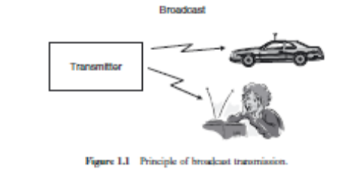
Figure 1.1 Principle of broadcast transmission.
1. The information is only sent in one direction. It is only the broadcast station that sendsinformation to the radio or TV receivers; the listeners (or viewers) do not transmit any information back to the broadcast station.
2. The transmitted information is the same for all users.
3. The information is transmitted continuously.
4. In many cases, multiple transmitters send the same information. This is especially true in Europe, where national broadcast networks cover a whole country and broadcast the same program in every part of that country.
The above properties led to a great many simplifications in the design of broadcast radio networks.The transmitter does not need to have any knowledge or consideration about the receivers.There is no requirement to provide for duplex channels (i.e., for bringing information from the receiver to the transmitter). The number of possible users of the service does not influence the transmitter structure either – irrespective of whether there are millions of users, or just a single one, the transmitter sends out the same information. The above description has been mainly true for traditional broadcast TV and radio. Satellite TV and radio differ in the fact that often the transmissions are intended only for a subset of all possible users (pay-TV or pay-per-view customers), and therefore, encryption of the content is required in order to prevent unauthorized viewing. Note, however, that this “privacy” problem is different from regular cellphones: for pay-TV, the content should be accessible to all members of the authorized user group, (“multicast”) while for cellphones, each call should be accessible only for the single person it is intended for (“unicast”) and not to all customers of a network provider.Despite their undisputed economic importance, broadcast networks are not at the center of interest for this book – space restrictions prevent a more detailed discussion. Still, it is useful to keep in mind that they are a specific case of wireless information transmission, and recent developments, like simulcast digital TV, interactive TV, and especially streaming TV to computers and cellphones, tend to obscure the distinction from cellular telephony even more.
1.2.2 Paging
Similar to broadcast, paging systems are unidirectional wireless communications systems. They arecharacterized by the following properties (see also Figure 1.2):
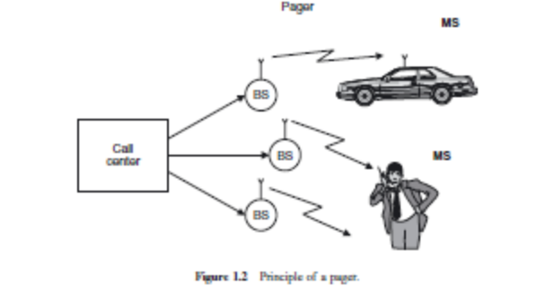
1. The user can only receive information, but cannot transmit. Consequently, a “call” (message) can only be initiated by the call center, not by the user.
2. The information is intended for, and received by, only a single user.
3. The amount of transmitted information is very small. Originally, the received information consisted of a single bit of information, which indicated to the user that “somebody has sent you a
message.” The user then had to make a phone call (usually from a payphone) to the call center, where a human operator repeated the content of the waiting message. Later, paging systems became more sophisticated, allowing the transmission of short messages (e.g., a different phone number that should be called, or the nature of an emergency). Still, the amount of information was rather limited.
Due to the unidirectional nature of the communications, and the small amount of information, the bandwidth required for this service is small. This in turn allows the service to operate at lowercarrier frequencies – e.g., 150MHz – where only small amounts of spectrum are available. As we will see later on, such lower carrier frequencies make it much easier to achieve good coverage of
a large area with just a few transmitters. Pagers were very popular during the 1980s and early 1990s. For some professional groups, like doctors, they were essential tools of the trade, allowing them to react to emergencies in shorter time. However, the success of cellular telephony has considerably reduced their appeal. Cellphones allow provision of all the services of a pager, plus many other features as well. The main appeal of paging systems, after the year 2000, lies in the better area coverage that they can achieve.
1.2.3 Cellular Telephony
Cellular telephony is the economically most important form of wireless communications. It is characterized by the following properties:
1. The information flow is bidirectional. A user can transmit and receive information at the same time.
Due to this reason, this book often draws its examples from cellular telephony, even though the general principles are applicable to other wireless systems as well. Chapters 24–28 give a detailed description of the most popular cellular systems.
1.2.4 Trunking Radio
Trunking radio systems are an important variant of cellular phones, where there is no connection between the wireless system and the PSTN; therefore, it allows the communications of closed user groups. Obvious applications include police departments, fire departments, taxis, and similar services. The closed user group allows implementation of several technical innovations that are not possible (or more difficult) in normal cellular systems:
1. Group calls: a communication can be sent to several users simultaneously, or several users can set up a conference call between multiple users of the system.
2. Call priorities: a normal cellular system operates on a “first-come, first-serve” basis. Once a call is established, it cannot be interrupted.6 This is reasonable for cellphone systems, where the network operator cannot ascertain the importance or urgency of a call. However, for the trunk radio system of, e.g., a fire department, this is not an acceptable procedure. Notifications of emergencies have to go through to the affected parties, even if that means interrupting an existing, lower priority call. A trunking radio system thus has to enable the prioritization of calls and has to allow dropping a low-priority call in favor of a high-priority one.
3. Relay networks: the range of the network can be extended by using each Mobile Station (MS) as a relay station for other MSs. Thus, an MS that is out of the coverage region of the BS might send its information to another MS that is within the coverage region, and that MS will forward the message to the BS; the system can even use multiple relays to finally reach the BS. Such an approach increases the effective coverage area and the reliability of the network. However, it can only be used in a trunking radio system and not in a cellular system – normal cellular users would not want to have to spend “their” battery power on relaying messages for other users.
1.2.5 Cordless Telephony
Cordless telephony describes a wireless link between a handset and a BS that is directly connected to the public telephone system. The main difference from a cellphone is that the cordless telephone is associated with, and can communicate with, only a single BS (see Figure 1.4). There is thus no mobile switching center; rather, the BS is directly connected to the PSTN. This has several important consequences:
1. The BS does not need to have any network functionality. When a call is coming in from the PSTN, there is no need to find out the location of the MS. Similarly, there is no need to provide for handover between different BSs.
2. There is no central system. A user typically has one BS for his/her apartment or business under control, but no influence on any other BSs. For that reason, there is no need for (and no possibility for) frequency planning.
3. The fact that the cordless phone is under the control of the user also implies a different pricing structure: there are no network operators that can charge fees for connections from the MS to the BS; rather, the only occurring fees are the fees from the BS into the PSTN.
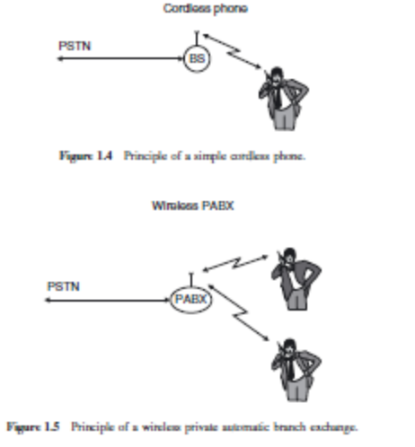
In many other respects, the cordless phone is similar to the cellular phone: it allows mobility within the cell area; the information flow is bidirectional; calls can originate from either the PSTN or the mobile user, and there have to be provisions such that calls cannot be intercepted or listened to by unauthorized users and no unauthorized calls can be made. Cordless systems have also evolved into wireless Private Automatic Branch eXchanges (PABXs) (see Figure 1.5). In its most simple form, a PABX has a single BS that can serve several handsets simultaneously – either connecting them to the PSTN or establishing a connection between them (for calls within the same company or house). In its more advanced form, the PABX contains several BSs that are connected to a central control station. Such a system has essentially the same functionality as a cellular system; it is only the size of the coverage area that distinguishes such a full functionality wireless PABX from a cellular network. The first cordless phone systems were analog systems that just established a simple wireless link between a handset and a BS; often, they did not even provide rudimentary security (i.e., stopping unauthorized calls). Current systems are digital and provide more sophisticated functionality. In Europe, the Digital Enhanced Cordless Telecommunications (DECT) system (see the companion website at www.wiley.com/go/molisch) is the dominant standard; Japan has a similar system called the Personal Handyphone System (PHS) that provides both the possibility for cordless telephony and an alternative cellular system (a full functionality PABX system that covers most of Japan and provides the possibility of public access). Both systems operate in the 1,800-MHz band, using a spectrum specifically dedicated to cordless applications. In the U.S.A., digital cordless phones mainly operate in the 2.45-GHz Industrial, Scientific, and Medical (ISM) band, which they share with many other wireless services.
1.2.6 Wireless Local Area Networks
The functionality of Wireless Local Area Networks (WLANs) is very similar to that of cordless phones – connecting a single mobile user device to a public landline system. The “mobile user device” in this case is usually a laptop computer and the public landline system is the Internet. As in the cordless phone case, the main advantage is convenience for the user, allowing mobility. Wireless LANs can even be useful for connecting fixed-location computers (desktops) to the Internet, as they save the costs for laying cables to the desired location of the computer.
A major difference between wireless LANs and cordless phones is the required data rate. While cordless phones need to transmit (digitized) speech, which requires at most 64 kbit/s, wireless LANs should be at least as fast as the Internet that they are connected to. For consumer (home) applications, this means between 700 kbit/s (the speed of DSLs in the U.S.A.) and 3–5 Mbit/s (speed of cable providers in the U.S.A. and Europe) to ≥20 Mbit/s (speed of DSLs in Japan). For companies that have faster Internet connections, the requirements are proportionately higher. In order to satisfy the need for these high data rates, a number of standards have been developed, all of which carry the identifier IEEE 802.11. The original IEEE 802.11 standard enabled transmission with 1Mbit/s, the very popular 802.11b standard (also known under the name WiFi) allows up to 11 Mbit/s and the 802.11a standard extends that to 55 Mbit/s. Even higher rates are realized by the 802.11n standard that was introduced in 2008/2009. WLAN devices can, in principle, connect to any BS (access point) that uses the same standard. However, the owner of the access point can restrict the access – e.g., by appropriate security settings.
1.2.7 Personal Area Networks
When the coverage area becomes even smaller than that of WLANs, we speak of Personal Area Networks (PANs). Such networks are mostly intended for simple “cable replacement” duties. For example, devices following the Bluetooth standard allow to connect a hands-free headset to a phone without requiring a cable; in that case, the distance between the two devices is less than a meter. In such applications, data rates are fairly low (<1Mbit/s). Recently, wireless communications between components in an entertainment system (DVD player to TV), between computer and peripheral devices (printer, mouse), and similar applications have gained importance, and a number of standards for PANs have been developed by the IEEE 802.15 group. For these applications, data rates in excess of 100 Mbit/s are used.
Networks for even smaller distances are called Body Area Networks (BANs), which enable communications between devices located on various parts of a user’s body. Such BANs play an increasingly important role in the monitoring of patients’ health and of medical devices (e.g., pacemakers). We note finally that PANs and BANs can either have a network structure similar to a cellular approach or they can be ad hoc networks as discussed in Section 1.2.9.
1.2.8 Fixed Wireless Access
Fixed wireless access systems can also be considered as a derivative of cordless phones or WLANs, essentially replacing a dedicated cable connection between the user and the public landline system. The main difference from a cordless system is that (i) there is no mobility of the user devices and (ii) the BS almost always serves multiple users. Furthermore, the distances bridged by fixed wireless access devices are much larger (between 100m and several tens of kilometers) than those bridged by cordless telephones.
The purpose of fixed wireless access lies in providing users with telephone and data connections without having to lay cables from a central switching office to the office or apartment the user is in. Considering the high cost of labor for the cable-laying operations, this can be an economical approach. However, it is worth keeping in mind that most buildings, especially in the urban areas of developed countries, are already supplied by some form of cable – regular telephone cable, cable TV, or even optical fiber. Rulings of the telecom regulators in various countries have stressed that incumbent operators (owners of these lines) have to allow competing companies to use these lines As a consequence, fixed wireless access has its main market for covering rural areas, and for establishing connections in developing countries that do not have any wired infrastructure in place. In general, the business cases for fixed wireless has been disappointing (see “Burst of the Bubble” in Section 1.1.5). The IEEE 802.16 (WiMAX) standard tries to alleviate that problem by allowing some limited mobility in the system, and thus blurs the distinction from cellular telephony.
1.2.9 Ad hoc Networks and Sensor Networks
Up to now, we have dealt with “infrastructure-based” wireless communications, where certain components (base stations, TV transmitters, etc.) are intended by design to be in a fixed location, to exercise control over the network and interface with other networks. The size of the networks may differ (from LANs covering just one apartment to cellular networks covering whole countries), but the central principle of distinguishing between “infrastructure” and “user equipment” is common to them all. There is, however, an alternative in which there is only one type of equipment, and those devices, all of which may be mobile, organize themselves into a network according to their location and according to necessity. Such networks are called ad hoc networks (see Figure 1.6). There can still be “controllers” in an ad hoc network, but the choice of which device acts as master and which as slave is done opportunistically whenever a network is formed. There are also ad hoc networks without any hierarchy. While the actual transmission of the data (i.e., physical layer communication) is almost identical to that of the infrastructure-based networks, the medium access
and the networking functionalities are very different.
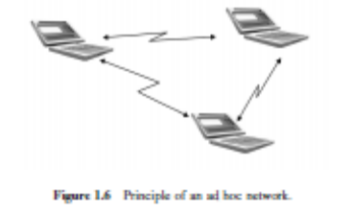
The advantages of ad hoc networks lie in their low costs (because no infrastructure is required) and high flexibility. The drawbacks include reduced efficiency, smaller communication range, and restrictions on the number of devices that can be included in a network. Ad hoc networks play a major role in the recent proliferation of sensor networks, which allow communications between machines for the purpose of building control (controlling air conditioning, lighting, etc., based on sensor data), factory automation, surveillance, etc. Ad hoc networks also play a role in emergency communications (when infrastructure was destroyed, e.g., by an earthquake) as well as military communications.
1.2.10 Satellite Cellular Communications
Besides TV, which creates the biggest revenues in the satellite market, cellular communications are a second important application of satellites. Satellite cellular communications mostly have the same operating principles as land-based cellular communications. However, there are some key differences. The distance between the “BS” (i.e., the satellite) and the MS is much larger: for geostationary satellites, that distance is 36,000 km; for Low Earth Orbit (LEO) satellites, it is several hundred kilometers. Consequently, the transmit powers need to be larger, high-gain antennas need to be used on the satellite (and in many cases also on the MS), and communications from within buildings is almost impossible.
Another important difference from the land-based cellular system lies in the cell size: due to the large distance between the satellite and the Earth, it is impossible to have cells with diameters less than 100 km even with LEO satellites; for geostationary satellites, the cell areas are even larger. This large cell size is the biggest advantage as well as the biggest drawback of the satellite systems. On the positive side, it makes it easy to have good coverage even of large, sparsely populated areas – a single cell might cover most of the Sahara region. On the other hand, the area spectral efficiency is very low, which means that (given the limited spectrum assigned to this service) only a few people can communicate at the same time. The costs of setting up a “BS” – i.e., a satellite – are much higher than for a land-based system. Not only is the launching of a communications satellite very expensive but it is also necessary to build up an appropriate infrastructure of ground stations for linking the satellites to the PSTN. As a consequence of all these issues, the business case for satellite communications systems is quite different: it is based on supplying a small number of users with vital communications at a much higher price. Emergency workers and journalists in disaster and war areas, ship-based communications, and workers on offshore oil drilling platforms are typical users for such systems The INMARSAT system is the leading provider for such communications. In the late 1990s, the IRIDIUM project attempted to provide lower priced satellite communications services by means of some 60 LEO satellites, but ended in bankruptcy.
- Explain the different types of requirements encountered in system design of various services.
1.3 Requirements for the Services
A key to understanding wireless design is to realize that different applications have different requirements in terms of data rate, range, mobility, energy consumption, and so on. It is not necessary to design a system that can sustain gigabit per second data rates over a 100-km range when the user is moving at 500 km/h. We stress this fact because there is a tendency among engineers to design a system that “does everything but wash the dishes”; while appealing from a scientific point of view, such systems tend to have a high price and low spectral efficiency. In the following, we list the range of requirements encountered in system design and we enumerate which requirements occur in which applications.
1.3.1 Data Rate
Data rates for wireless services span the gamut from a few bits per second to several gigabit per second, depending on the application:
Higher data rates are often required for the central nodes of sensor networks that collect the information from a large number of sensors and forward it for further processing. In that case, data rates of up to 10Mbit/s can be required. These “central nodes” show more similarity to WLANs or fixed wireless access.
• Speech communications usually require between 5 and 64 kbit/s depending on the required quality and the amount of compression. For cellular systems, which require higher spectral efficiency, source data rates of about 10 kbit/s are standard. For cordless systems, less elaborate compression and therefore higher data rates (32 kbit/s) are used.
• Elementary data services require between 10 and 100 kbit/s. One category of these services uses the display of the cellphone to provide Internet-like information. Since the displays are smaller, the required data rates are often smaller than for conventional Internet applications. Another type of data service provides a wireless mobile connection to laptop computers. In this case, speeds that are at least comparable with dial-up (around 50 kbit/s) are demanded by most users, though elementary services with 10 kbit/s (exploiting the same type of communications channels foreseen for speech) are sometimes used as well. Elementary data services are mostly replaced by high-speed data services in the U.S.A., Europe, and Japan, but still play an important role in other parts of the world.
• Communications between computer peripherals and similar devices: for the replacement of cables that link computer peripherals, like mouse and keyboard, to the computer (or similarly for cellphones), wireless links with data rates around 1Mbit/s are used. The functionality of these links is similar to the previously popular infrared links, but usually provides higher reliability.
• High-speed data services: WLANs and 3G cellular systems are used to provide fast Internet access, with speeds that range from 0.5 to 100 Mbit/s (currently under development).
• Personal Area Networks (PANs) is a newly coined term that refers mostly to the range of a wireless network (up to 10m), but often also has the connotation of high data rates (over 100 Mbit/s), mostly for linking the components of consumer entertainment systems (streaming video from computer or DVD player to a TV) or high-speed computer connections (wireless Universal Serial Bus (USB)).
1.3.2 Range and Number of Users
Another distinction among the different networks is the range and the number of users that they serve. By “range,” we mean here the distance between one transmitter and receiver. The coverage area of a system can be made almost independent of the range, by just combining a larger number of BSs into one big network.
• Body Area Networks (BANs) cover the communication between different devices attached to one body – e.g., from a cellphone in a hip holster to a headset attached to the ear. The range is thus on the order of 1m. BANs are often subsumed into PANs.
• Personal Area Networks include networks that achieve distances of up to or about 10 m, covering the “personal space” of one user. Examples are networks linking components of computers and home entertainment systems. Due to the small range, the number of devices within a PAN is small, and all are associated with a single “owner.” Also, the number of overlapping PANs (i.e., sharing the same space or room) is small – usually less than five. That makes cell planning and multiple access much simpler.
• WLANs, as well as cordless telephones cover still larger ranges of up to 100 m. The number of users is usually limited to about 10. When much larger numbers occur (e.g., at conferences or meetings), the data rates for each user decrease. Similarly, cordless phones have a range of up to 300m and the number of users connected to one BS is of the same order as for WLANs. however, that wireless PABXs can have much larger ranges and user numbers – as mentioned before, they can be seen essentially as small private cellular systems.
• Cellular systems have a range that is larger than, e.g., the range of WLANs. Microcells typically cover cells with 500m radius, while macrocells can have a radius of 10 or even 30 km. Depending on the available bandwidth and the multiple access scheme, the number of active users in a cell is usually between 5 and 50. If the system is providing high-speed data services to one user, the number of active users usually shrinks.
• Fixed wireless access services cover a range that is similar to that of cellphones – namely, between 100m and several tens of kilometers. Also, the number of users is of a similar order as for cellular systems.
• Satellite systems provide even larger cell sizes, often covering whole countries and even continents.
Cell size depends critically on the orbit of the satellite: geostationary satellites provide larger cell sizes (1,000-km radius) than LEOs.
Figure 1.7 gives a graphical representation of the link between data rate and range. Obviously, higher data rates are easier to achieve if the required range is smaller. One exception is fixed wireless access, which demands a high data rate at rather large distances.
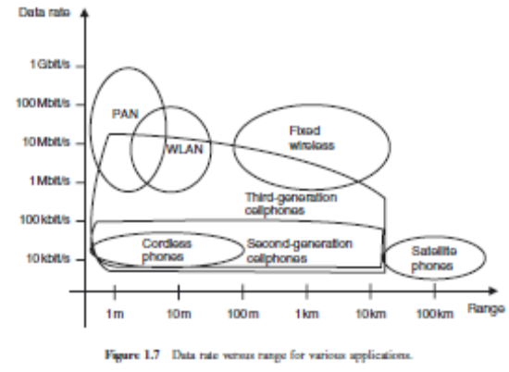
1.3.3 Mobility
Wireless systems also differ in the amount of mobility that they have to allow for the users. The ability to move around while communicating is one of the main charms of wireless communication for the user. Still, within that requirement of mobility, different grades exist:
• Fixed devices are placed only once, and after that time communicate with their BS, or with each other, always from the same location. The main motivation for using wireless transmission techniques for such devices lies in avoiding the laying of cables. Even though the devices are not mobile, the propagation channel they transmit over can change with time: both due to people walking by and due to changes in the environment (rearranging of machinery, furniture, etc.). Fixed wireless access is a typical case in point. Note also that all wired communications (e.g., the PSTN) fall into this category.
• Nomadic devices: nomadic devices are placed at a certain location for a limited duration of time (minutes to hours) and then moved to a different location. This means that during one “drop” (placing of the device), the device is similar to a fixed device. However, from one drop to the next, the environment can change radically. Laptops are typical examples: people do not operate their laptops while walking around, but place them on a desk to work with them. Minutes or hours later, they might bring them to a different location and operate them there.
• Low mobility: many communications devices are operated at pedestrian speeds. Cordless phones, as well as cellphones operated by walking human users are typical examples. The effect of the low mobility is a channel that changes rather slowly, and – in a system with multiple BSs – handover from one cell to another is a rare event.
• High mobility usually describes speed ranges from about 30 to 150 km/h. Cellphones operated by people in moving cars are one typical example.
• Extremely high mobility is represented by high-speed trains and planes, which cover speeds between 300 and 1000 km/h. These speeds pose unique challenges both for the design of the physical layer (Doppler shift, see Chapter 5) and for the handover between cells.
Figure 1.8 shows the relationship between mobility and data rate.
Figure 1.8 Data rate versus mobility for various applications.
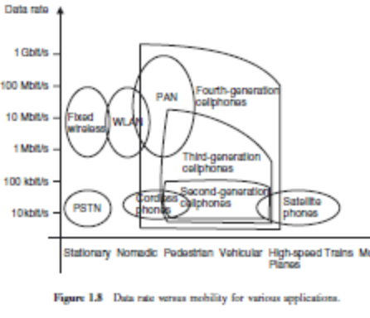
1.3.4 Energy Consumption
Energy consumption is a critical aspect for wireless devices. Most wireless devices use (one-way or rechargeable) batteries, as they should be free of any wires – both the ones used for communication and the ones providing the power supply.
• Rechargeable batteries: nomadic and mobile devices, like laptops, cellphones, and cordless phones, are usually operated with rechargeable batteries. Standby times as well as operating times are one of the determining factors for customer satisfaction. Energy consumption is determined on one hand by the distance over which the data have to be transmitted (remember that a minimum SNR has to be maintained), and on the other hand, by the amount of data that are to be transmitted (the SNR is proportional to the energy per bit). The energy density of batteries has increased slowly over the past 100 years, so that the main improvements in terms of operating and standby time stem from reduced energy consumption of the devices. For cellphones, talk times of more than 2 hours and standby times of more than 48 hours are minimum requirements. For laptops, power consumption is not mainly determined by the wireless transmitter, but rather by other factors like hard drive usage and processor speed. For smartphones, the energy consumption of the processor and of the wireless connection is of the same order, and both have to be considered for maximizing battery lifetime.
• One-way batteries: sensor network nodes often use one-way batteries, which offer higher energy density at lower prices. Furthermore, changing the battery is often not an option; rather, the sensor including the battery and the wireless transceiver is often discarded after the battery has run out. It is obvious that in this case energy-efficient operation is even more important than for devices with rechargeable batteries.
• Power mains: BSs and other fixed devices can be connected to the power mains. Therefore, energy efficiency is not a major concern for them. It is thus desirable, if possible, to shift as much functionality (and thus energy consumption) from the MS to the BS. User requirements concerning batteries are also important sales issues, especially in the market for cellular handsets:
• The weight of an MS is determined mostly (70–80%) by the battery. Weight and size of a handset are critical sales issues. It was in the mid-1980s that cellphones were commonly called “carphones,” because the MS could only be transported in the trunk of a car and was powered by the car battery. By the end of the 1980s, the weight and dimensions of the batteries had decreased to about 2 kg, so that it could be carried by the user in a backpack. By the year 2000, the battery weight had decreased to about 200 g. Part of this improvement stems from more efficient battery technology, but to a large part, it is caused by the decrease of the power consumption of the handsets.
• Also, the costs of a cellphone (raw materials) are determined to a considerable degree by the battery.
• Users require standby times of several days, as well as talk times of at least 2 hours before recharging.
These “commercial” aspects determine the maximum size (and thus energy content) of the battery, and consequently, the admissible energy consumption of the phone during standby and talk operation.
1.3.5 Use of Spectrum
Spectrum can be assigned on an exclusive basis, or on a shared basis. That determines to a large degree the multiple access scheme and the interference resistance that the system has to provide:
• Spectrum dedicated to service and operator: in this case, a certain part of the electromagnetic spectrum is assigned, on an exclusive basis, to a service provider. A prime point in case is cellular telephony, where the network operators buy or lease the spectrum on an exclusive basis (often for a very high price). Due to this arrangement, the operator has control over the spectrum and can plan the use of different parts of this spectrum in different geographical regions, in order to minimize interference.
• Spectrum allowing multiple operators:
◦ Spectrum dedicated to a service: in this case, the spectrum can be used only for a certain service (e.g., cordless telephones in Europe and Japan), but is not assigned to a specific operator. Rather, users can set up qualified equipment without a license. Such an approach does not require (or allow) interference planning. Rather, the system must be designed in such a way that it avoids interfering with other users in the same region. Since the only interference can come from equipment of the same type, coordination between different devices is relatively simple. Limits on transmit power (identical for all users) are a key component of this approach – without them, each user would just increase the transmit power to drown out interferers, leading essentially to an “arms race” between users.
◦ Free spectrum: is assigned for different services as well as for different operators. The ISM band at 2.45 GHz is the best known example – it is allowed to operate microwave ovens, WiFi LANs, and Bluetooth wireless links, among others, in this band. Also for this case, each user has to adhere to strict emission limits, in order not to interfere too much with other systems and users. However, coordination between users (in order to minimize interference) becomes almost impossible – different systems cannot exchange coordination messages with each other, and often even have problems determining the exact characteristics (bandwidth, duty cycle) of the interferers. After 2000, two new approaches have been promulgated, but are not yet in widespread use:
• Ultra Wide Bandwidth systems (UWB) spread their information over a very large bandwidth, while at the same time keeping a very low-power spectral density. Therefore, the transmit band can include frequency bands that have already been assigned to other services, without creating significant interference.
• Adaptive spectral usage: another approach relies on first determining the current spectrum usage at a certain location and then employing unused parts of the spectrum. This approach, also known as cognitive radio, .
1.3.6 Direction of Transmission
Not all wireless services need to convey information in both directions.
• Simplex systems send the information only in one direction – e.g., broadcast systems and pagers.
• Semi-duplex systems can transmit information in both directions. However, only one direction is allowed at any time. Walkie-talkies, which require the user to push a button in order to talk, are a typical example. Note that one user must signify (e.g., by using the word “over”) that (s)he has finished his/her transmission; then the other user knows that now (s)he can transmit.
• Full-duplex systems allow simultaneous transmission in both directions – e.g., cellphones and cordless phones.
• Asymmetric duplex systems: for data transmission, we often find that the required data rate in one irection (usually the downlink) is higher than in the other direction. However, even in this case, full duplex capability is maintained.
1.3.7 Service Quality
The requirements for service quality also differ vastly for different wireless services. The first main indicator for service quality is speech quality for speech services and file transfer speed for data services. Speech quality is usually measured by the Mean Opinion Score (MOS). It represents the average of a large number of (subjective) human judgments (on a scale from 1 to 5) about the quality of received speech (see also Chapter 15). The speed of data transmission is simply measured
in bit/s – obviously, a higher speed is better. An even more important factor is the availability of a service. For cellphones and other speech services, the service quality is often computed as the complement of “fraction of blocked calls7 plus 10 times the fraction of dropped calls.” This formula takes into account that the dropping of an active call is more annoying to the user than the inability to make a call at all. For cellular systems in Europe and Japan, this service quality measure usually exceeds 95%; in the U.S.A., the rate is considerably lower.
For emergency services and military applications, service quality is better measured as the complement of “fraction of blocked calls plus fraction of dropped calls.” In emergency situations, the inability to make a call is as annoying as the situation of having a call interrupted. Also, the systems must be planned in a much more robust way, as service qualities better than 99% are required. “Ultrareliable systems,” which are required, e.g., for factory automation systems, require service quality in excess of 99.99%.
A related aspect is the admissible delay (latency) of the communication. For voice communications, the delay between the time when one person speaks and the other hears the message must not be larger than about 100 ms. For streaming video and music, delays can be larger, as buffering of the streams (up to several tens of seconds) is deemed acceptable by most users. In both voice and streaming video communications, it is important that the data transmitted first are also the ones made available to the receiving user first. For data files, the acceptable delays can be usually larger and the sequence with which the data arrive at the receiver is not critical (e.g., when downloading email from a server, it is not important whether the first or the seventh of the emails is the first to arrive). However, there are some data applications where small latency is vital – e.g., for control applications, security and safety monitoring, etc.
- What is fading? Explain the types of fading.
A simple RX cannot distinguish between the different Multi Path Components (MPCs); it just adds them up, so that they interfere with each other. The interference between them can be constructive or destructive, depending on the phases of the MPCs, (see Figure 2.2). The phases, in turn, depend mostly on the run length of the MPC, and thus on the position of the Mobile Station (MS) and the IOs. For this reason, the interference, and thus the amplitude of the total signal, changes with time if either TX, RX, or IOs is moving. This effect – namely, the changing of the total signal amplitude due to interference of the different MPCs – is called small-scale fading. At 2-GHz carrier frequency, a movement by less than 10 cm can already effect a change from constructive to destructive interference and vice versa. In other words, even a small movement can result in a large change in signal amplitude. A similar effect is known to all owners of car radios – moving the car by less than 1m (e.g., in stop-and-go traffic) can greatly affect the quality of the received signal.
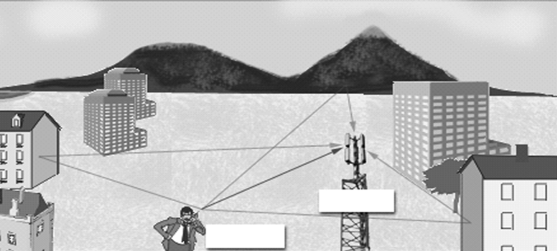
For cellphones, it can often be sufficient to move one step in order to improve signal quality. As an additional effect, the amplitudes of each separate MPC change with time (or with location). Obstacles can lead to a shadowing of one or several MPCs. Imagine, e.g., the MS in Figure 2.3 that at first (at position A) has LOS to the Base Station (BS). As the MS moves behind the high-rise building (at position B), the amplitude of the component that propagates along the direct connection (LOS) between BS and MS greatly decreases. This is due to the fact that the MS is now in the radio shadow of the high-rise building, and any wave going through or around that building is greatly attenuated – an effect called shadowing. Of course, shadowing can occur not only for an LOS component but also for any MPC. Note also that obstacles do not throw “sharp” shadows: the transition from the “light” (i.e., LOS) zone to the “dark” (shadowed) zone is gradual.1 The MS has to move over large distances (from a few meters up to several hundreds of meters) to move from the light to the dark zone. For this reason, shadowing gives rise to large-scale fading. Large-scale and small-scale fading overlap, so that the received signal amplitude can look like the one depicted in fig.
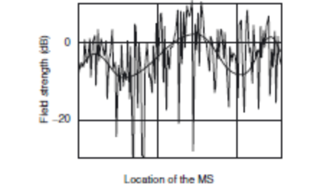
Obviously, the transmission quality is low at the times (or places) with low signal amplitude. This can lead to bad speech quality (for voice telephony), high Bit Error Rate (BER) and low data rate (for data transmission), and – if the quality is too low for an extended period of time – to termination of the connection.
- Discuss the different approaches used for the efficient usage of spectrum.
Since spectrum is limited, the same spectrum has to be used for different wireless connections in different locations. To simplify the discussion, let us consider in the following a cellular system where different connections (different users) are distinguished by the frequency channel (band around a certain carrier frequency) that they employ. If an area is served by a single BS, then the available spectrum can be divided into N frequency channels that can serve N users simultaneously. If more than N users are to be served, multiple BSs are required, and frequency channels have to be reused in different locations. For this purpose, we divide the area (a region, a country, or a whole continent) into a number of cells; we also divide the available frequency channels into several groups. The channel groups are now assigned to the cells. The important thing is that channel groups can be used in multiple cells. The only requirement is that cells that use the same frequency group do not interfere with each other significantly.7 It is fairly obvious that the same carrier frequency can be used for different connections in, say, Rome and Stockholm, at the same time. The large distance between the two cities makes sure that a signal from the MS in Stockholm does not reach the BS in Rome, and can therefore not cause any interference at all. But in order to achieve high efficiency, frequencies must actually be reused much more often – typically, several times within each city. Consequently, intercell interference (also known as co-channel interference) becomes a dominant factor that limits transmission quality. More details on co-channel interference can be found in Part IV. Spectral efficiency describes the effectiveness of reuse – i.e., the traffic density that can be achieved per unit bandwidth and unit area. It is therefore given in units of Erland/(Hzm2) for voice traffic and bit/(sHzm2) for data. Since the area covered by a network provider, as well as the bandwidth that it can use, are fixed, increasing the spectral efficiency is the only way to increase the number of customers that can be served, and thus revenue. Methods for increasing this spectral efficiency are thus at the center of wireless communications research. Since a network operator buys a license for a spectrum, it can use that spectrum according to its own planning – i.e., network planning can make sure that the users in different cells do not interfere with each other significantly. The network operator is allowed to use as much transmit power as it desires; it can also dictate limits on the emission power of the MSs of different users. The operator can also be sure that the only interference in the network is created by its own network and users.
In contrast to regulated spectrum, several services use frequency bands that are available to the general public. For example, some WLANs operate in the 2.45-GHz band, which has been assigned to “ISM” services. Anybody is allowed to transmit in these bands, as long as they (i) limit the emission power to a prescribed value, (ii) follow certain rules for the signal shape and bandwidth, and (iii) use the band according to the (rather broadly defined) purposes stipulated by the frequency regulators. As a consequence, a WLAN receiver can be faced with a large amount of interference. This interference can either stem from other WLAN transmitters or from microwave ovens, cordless
phones, and other devices that operate in the ISM band. For this reason, a WLAN link must have the capability to deal with interference. That can be achieved by selecting a frequency band within the ISM band at which there is little interference, by using spread spectrum techniques , or some other appropriate technique. There are also cases where the spectrum is assigned to a specific service (e.g., DECT), but not to a specific operator. In that case, receivers might still have to deal with strong interference, but the structure of this interference is known. This allows the use of special interference mitigation techniques like dynamic frequency assignment.
- Write short notes on (i)noise limited system (ii)interference limited system
Noise-Limited Systems
Wireless systems are required to provide a certain minimum transmission quality. This transmission quality in turn requires a minimum Signal-to-Noise Ratio (SNR) at the receiver (RX). Consider now a situation where only a single BS transmits, and a Mobile Station (MS) receives; thus, the performance of the system is determined only by the strength of the (useful) signal and the noise. As the MS moves further away from the BS, the received signal power decreases, and at a certain distance, the SNR does not achieve the required threshold for reliable communications. Therefore, the range of the system is noise limited; equivalently, we can call it signal power limited . Depending on the interpretation, it is too much noise or too little signal power that leads to bad link quality. Let us assume for the moment that the received power decreases with d2, the square of the
distance between BS and MS. More precisely, let the received power PRX be
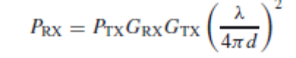 (3.1)
where GRX and GTX are the gains of the receive and transmit antennas, respectively,1 λ is the wavelength, and PTX is the transmit power.
The noise that disturbs the signal can consist of several components, as follows:
1. Thermal noise: The power spectral density of thermal noise depends on the environmental temperature Te that the antenna “sees.” The temperature of the Earth is around 300 K, while the temperature of the (cold) sky is approximately Te ≈ 4K (the temperature in the direction of the Sun is of course much higher). As a first approximation, it is usually assumed that the environmental temperature is isotropically 300 K. Noise power spectral density is then
N0 = kBTe (3.2)
where kB is Boltzmann’s constant, kB = 1.38 ・ 10−23 J/K, and the noise power is
Pn = N0B (3.3)
where B is RX bandwidth (in units of Hz). It is common to write Eq. (3.2) using logarithmic units (power P expressed in units of dBm is 10 log10 (P/1 mW)):
N0 = −174 dBm/Hz (3.4)
This means that the noise power contained in a 1-Hz bandwidth is −174 dBm. The noise power contained in bandwidth B is
−174 + 10 log10(B) dBm (3.5)
The logarithm of bandwidth B, specifically 10 log10(B), has the units dBHz. 2. Man-made noise: We can distinguish two types of man-made noise:
(a) Spurious emissions: Many electrical appliances as well as radio transmitters (TXs) designed for other frequency bands have spurious emissions over a large bandwidth that includes the frequency range in which wireless communications systems operate. For urban outdoor environments, car ignitions and other impulse sources are especially significant sources of noise. In contrast to thermal noise, the noise created by impulse sources decreases with frequency (see Figure 3.1). At 150 MHz, it can be 20 dB stronger than thermal noise; at 900 MHz, it is typically 10 dB stronger. At Universal Mobile Telecommunications System (UMTS) frequencies, Neubauer et al. [2001] measured 5-dB noise enhancement by manmade noise in urban environments and about 1 dB in rural environments. Note that frequency regulators in most countries impose limits on “spurious” or “out-of-band” emissions for all electrical devices. Furthermore, for communications operating in licensed bands, such spurious emissions are the only source of man-made noise. It lies in the nature of the license (for which the license holder usually has paid) that no other intentional emitters are allowed to operate in this band. In contrast to thermal noise, man-made noise is not necessarily Gaussian distributed. However, as a matter of convenience, most system-planning tools, as well as theoretical designs, assume Gaussianity anyway.
(b) Other intentional emission sources: Several wireless communications systems operate in unlicensed bands. In these bands, everybody is allowed to operate (emit electromagnetic radiation) as long as certain restrictions with respect to transmit power, etc. are fulfilled. The most important of these bands is the 2.45-GHz Industrial, Scientific, and Medical (ISM) band. The amount of interference in these bands can be considerable.
3. Receiver noise: The amplifiers and mixers in the RX are noisy, and thus increase the total noise power. This effect is described by the noise figure F, which is defined as the SNR at the RX input (typically after downconversion to baseband) divided by the SNR at the RX output. As the amplifiers have gain, noise added in the later stages does not have as much of an impact as noise added in the first stage of the RX. Mathematically, the total noise figure Feq of a cascade of components is\
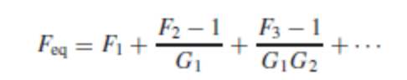
where Fi and Gi are noise figures and noise gains of the individual stages in absolute units (not in decibels (dB)). Note that for this equation, passive components, like attenuators with gain m < 1, can be interpreted as either having a noise figure of F = 1/m and unit gain of G = 1, or unit noise figure F = 1, and gain G = m.
Interference-Limited Systems
Consider now the case that the interference is so strong that it completely dominates the performance, so that the noise can be neglected. Let a BS cover an area (cell) that is approximately described by a circle with radius R and center at the location of the BS. Furthermore, there is an interfering TX at distance D from the “desired” BS, which operates at the same frequency, and with the same transmit power. How large does D have to be in order to guarantee satisfactory transmission quality 90% of the time, assuming that the MS is at the cell boundary (worst case)? The computations follow the link budget computations of the previous section.
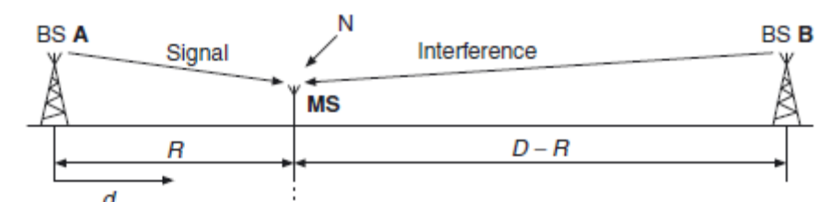
- What is link budget? Explain with an example how it can be computed for noise limited system.
A link budget is the clearest and most intuitive way of computing the required TX power. It tabulates all equations that connect the TX power to the received SNR. As most factors influencing the SNR enter in a multiplicative way, it is convenient to write all the equations in a logarithmic form – specifically, in dB. It has to be noted, however, that the link budget gives only an approximation (often a worst case estimate) for the total SNR, because some interactions between different effects are not taken into account.
the following points should be stressed:
• Chapters 4 and 7 provide extensive discussions of path loss, i.e., the attenuation due to propagation effects, between TX and RX. For the purpose of this chapter, we use a simple model, the so-called “breakpoint” model. For distances d < dbreak, the received power is proportional to 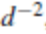 according to Eq. (3.1). Beyond that point, the power is proportional to , where n typically lies between 3.5 and 4.5. The received power is thus
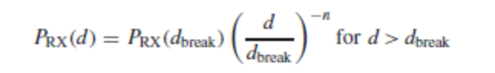
• Wireless systems, especially mobile systems, suffer from temporal and spatial variations of the transmission channel (fading) (see Section 2.1). In other words, even if the distance is approximately constant, the received power can change significantly with small movements of the 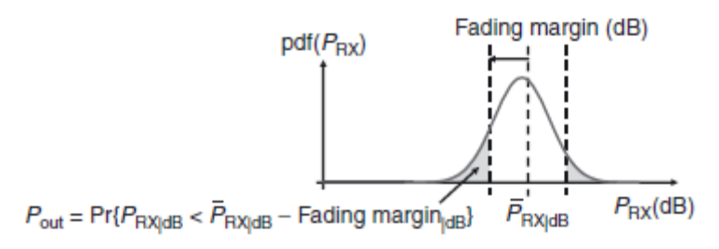
TX and/or RX. The power computed from Eq. (3.8) is only a mean value; the ratio of the transmit power to this mean received power is also known as the path loss (inverse of the path gain). If the mean received power is used as the basis for the link budget, then the transmission quality will be above the threshold only in approximately 50% of the times and locations.2 This is completely unacceptable quality of service. Therefore, we have to add a fading margin, which makes sure that the minimum received power is exceeded in at least, e.g., 90% of all cases The value of the fading margin depends on the amplitude statistics of the fading.
• Uplink (MS to BS) and downlink (BS to MS) are reciprocal, in the sense that the voltage and currents at the antenna ports are reciprocal (as long as uplink and downlink use the same carrier frequency). However, the noise figures of BSs and MSs are typically quite different. As MSs have to be produced in quantity, it is desirable to use low-cost components, which typically have higher noise figures. Furthermore, battery lifetime considerations dictate that BSs can emit more power than MSs. Finally, BSs and MSs differ with respect to antenna diversity, how close they are to interferers, etc. Thus, the link budgets of uplinks and downlinks are different.
- Compare the different multiple access schemes.
Frequency Division Multiple Access
FDMA is the oldest, and conceptually most simple, multiaccess method. Each user is assigned a frequency (sub)band – i.e., a (usually contiguous) part of the available spectrum. The assignment of frequency bands is usually done during call setup, and retained during the whole call. FDMA is usually combined with the Frequency Domain Duplexing (FDD), so that two frequency bands (with a fixed duplex distance) are assigned to each user: one for downlink (BS-to-MS) and one for uplink (MS-to-BS) communication. Pure FDMA is conceptually very simple, and has some advantages for implementation:
• The transmitter (TX) and receiver (RX) require little digital signal processing. However, this is not so important in practice anymore, as the costs for digital processing are continuously decreasing.
• (Temporal) synchronization is simple. Once synchronization has been established during the call setup, it is easy to maintain it by means of a simple tracking algorithm, as transmission occurs continuously. However, pure FDMA also has significant disadvantages, especially when used for speech communications. These problems arise from spectral efficiency considerations, as well as from sensitivity to multipath effects:
• Frequency synchronization and stability are difficult: for speech communications, each frequency subband is quite narrow (typically between 5 and 30 kHz). Local oscillators thus must be very accurate and stable; jitters in the carrier frequency result in adjacent channel interference. High spectral efficiency also requires the use of very steep filters to extract the desired signal. Both accurate oscillators and steep filters are expensive, and thus undesirable. If they are not admissible, guard bands can be used to mitigate filter requirements. This, however, reduces the spectral efficiency of the system.
• Sensitivity to fading: since each user is assigned a distinct frequency band, these bands are narrower than for other multiaccess methods (compare TDMA, CDMA) – i.e., 5–30 kHz. For such narrow subbands, fading is flat in practically all environments. This has the advantage that no equalization is required; the drawback is that there is no frequency diversity. Remember that frequency diversity is mainly provided by signal components that are more than one channel coherence bandwidth apart.
• Sensitivity to random Frequency Modulation (FM): due to the narrow bandwidth, the system is sensitive to random FM: the Bit Error Rate (BER) due to random FM is proportional to (νmaxTS )2 Thus, it is inversely proportional to the square of the bandwidth. On the positive side, appropriate signal-processing schemes can not only mitigate these effects but even exploit them to obtain time diversity. Note that the situation here is dual to wideband systems, where delay dispersion can be a drawback, but equalizers can turn them into an asset by exploiting frequency diversity.
• Intermodulation: the BS needs to transmit multiple speech channels, each of which is active the whole time. Typically, a BS uses 20–100 frequency channels. If these signals are amplified by the same power amplifier, third-order modulation products can be created, which lie at undesirable frequencies – i.e., within the transmit band. We thus need either a separate amplifier for each speech channel, or a highly linear amplifier for the composite signal – each of these solutions makes a BS more expensive.
Time Division Multiple Access
For TDMA, different users transmit not at different frequencies but rather at different times. A time unit is subdivided into N timeslots of fixed duration, and each user is assigned one such timeslot.During the assigned timeslot, the user can transmit with a high data rate (as it can use the whole system bandwidth); subsequently, it remains silent for the next N − 1 timeslots, when other users take their turn. This process is then repeated periodically. At first glance, this approach has the same performance as FDMA: a user transmits only during 1/N of the available time, but then occupies N times the bandwidth. However, there are some important practical differences:
• Users occupy a larger bandwidth. This allows them to exploit the frequency diversity available within the bandwidth allocated to the system; furthermore, the sensitivity to random FM is reduced. On the flipside, equalizers are required to combat InterSymbol Interference (ISI) for most operating environments; this increases the effort needed for digital signal processing.
• Temporal guard intervals are required. A TX needs a finite amount of time to ramp up from 0-W output power to “full power” (typically between 100mW and 100 W). Furthermore, there has to be sufficient guard time to compensate for the runtime of the signal between the MS and BS. It is possible that one MS is far away from the BS, while the one that transmits in the subsequent timeslot is very close to the BS and thus has negligible runtime. As the signals from the two users must not overlap at the BS, the second MS must not transmit during the time it takes the first signal to propagate to the BS.3 Note, however, that there is no need for frequency guard bands, as each user completely fills up the assigned band.
• Each timeslot might require a new synchronization and channel estimation, as transmission is not continuous. Optimization of timeslot duration is a challenging task. If it is too short, then a large percentage of the time is used for synchronization and channel estimates (in GSM, 17% of a timeslot are used for this purpose). If the timeslot is too long, transmission delays become too long (which users find annoying especially for speech communications), and the channel starts to change during one timeslot. In that case, the equalizer has to track the channel during transmission of a timeslot, which increases implementation effort (this was required, e.g., in the – now defunct – Interim Standard (IS)-136 cellular standard). If the time between two timeslots assigned to one user is larger than coherence time, the channel has changed between these two timeslots, and a new channel estimate is required.
• For interference-limited systems, TDMA has a major advantage: during its period of inactivity, the MS can “listen” to transmission on other timeslots.4 This is especially useful for the preparation of handovers from one BS to another, when the MS has to find out whether a neighboring BS would offer better quality, and has communications channels available.
Carrier Sense Multiple Access
A TX can determine (sense) whether the channel is currently occupied by another user (carrier). This knowledge can be used to increase the efficiency of a packet-switched system: if one user is transmitting, no other user is allowed to send a signal. Such a method is called CSMA. It is more efficient than ALOHA, because a TX does not disturb other users that are already on the air. The most important parameters of a CSMA system are detection delay and propagation delay.
Detection delay is a relative measure for how long it takes a TX to determine whether the channel is currently occupied. It depends essentially on the hardware of the system, but also on the desired false alarm probability and the SNR. Propagation delay is the measure of how long a data packet takes to get from the MS to the BS. It can happen that at time t1, TX 1 determines that the channel is free, and thus sends off a packet. At time t2 another TX senses the channel. If t2 − t1 is shorter than the time it takes data packet A to get from TX 1 to TX 2, then TX 2 determines that the channel is free, and sends off data packet B. In such a case a collision occurs. This description makes it clear that detection delay and propagation delay should be much smaller than packet duration.
- What is CSMA? Explain the different methods of implementing CSMA.
A TX can determine (sense) whether the channel is currently occupied by another user (carrier). This knowledge can be used to increase the efficiency of a packet-switched system: if one user is transmitting, no other user is allowed to send a signal. Such a method is called CSMA. It is more efficient than ALOHA, because a TX does not disturb other users that are already on the air. The most important parameters of a CSMA system are detection delay and propagation delay.
Detection delay is a relative measure for how long it takes a TX to determine whether the channel is currently occupied. It depends essentially on the hardware of the system, but also on the desired false alarm probability and the SNR. Propagation delay is the measure of how long a data packet takes to get from the MS to the BS. It can happen that at time t1, TX 1 determines that the channel is free, and thus sends off a packet. At time t2 another TX senses the channel. If t2 − t1 is shorter than the time it takes data packet A to get from TX 1 to TX 2, then TX 2 determines that the channel is free, and sends off data packet B. In such a case a collision occurs. This description makes it clear that detection delay and propagation delay should be much smaller than packet duration.
Implementation of Carrier Sense Multiple Access
There are different methods of implementing CSMA.
• Nonpersistent CSMA: the TX senses the channel. If the channel is busy, the TX waits a random time duration until retransmission.
• p-Persistent CSMA: this method is applied in slotted channels. When a TX determines that a channel is available, it transmits with probability p in the subsequent frame; otherwise, it transmits one timeslot later.
• 1-Persistent CSMA: the TX constantly senses the channel, until it realizes that the channel is free; then it immediately sends off the packet. This is obviously a special case of p-persistent transmission, with p = 1.
• CSMA with collision detection: in this method, a node observes whether two TXs start to transmit simultaneously. If that is the case, transmission is immediately terminated. This approach is not commonly used for wireless packet radio.
• Data Sense Multiple Access (DSMA): in this approach, the downlink includes a control channel, which transmits at periodic intervals a “busy/available” signal that indicates the state of the channel. If a user finds the channel to be free, it can immediately send off a data packet. Note that for peer-to-peer networks, implementation of the control channel is more difficult than in a scenario with a central node (BS).
- Explain the concept of cell planning with relevant diagrams and expressions.
In a cellular system, the coverage area is divided into many small areas called “cells.” In each of these cells, there is one BS that provides coverage for this (and only this) cell area. Now, each frequency channel can be used in multiple cells. The question that naturally arises is: can we use each frequency channel in each cell? Typically, the answer is “no.” Imagine the situation where user A is at the boundary of its assigned cell, so that distances from the “useful” BS and from a neighboring BS are the same. If the neighboring BS transmits in the same frequency channel order to communicate with user B in its own cell), then the SIR seen by user A is C/I = 0dB.This is certainly not enough to sustain reliable communications, especially since 0 dB is the median SIR, and fading makes the situation worse 50% of the time. The solution to this problem is to reuse a frequency channel not in every cell, but only in cells that have a certain minimum distance from each other. The normalized distance between two cells that can use the same frequency channels is called the reuse distance, D/R. This reuse distance can be computed from link budgets (as described in Section 3.2). We can also define a cluster of cells that all use different frequencies; therefore, there can be no co-channel interference within such a cluster. The number of cells in a cluster is called the cluster size. The total coverage area is divided into such clusters. The cluster size also determines the capacity of the cellular system. An operator that has licenses for 35 frequency channels, and uses cluster size 7, can support 5 simultaneous users in each cell. Maximization of capacity thus requires minimization of cluster size. Cluster size 1 (i.e., using each frequency in each cell) is the ultimate goal; however, we have seen above that this is not possible in an FDMA system due to the required link margins. Analog FDMA systems typically require an SIR of 18 dB, which results in a cluster size of 21 (see below). Digital systems like GSM require less than 10 dB, which decreases the reuse distance to 7 or less. This allows a dramatic increase in capacity, and was one of the most important reasons for the shift from analog to digital cellular systems in the early 1990s.
- Explain the various methods that increase the system capacity.
System capacity is the most important measure for a cellular network. Methods for increasing capacity are thus an essential area of research.
1. Increasing the amount of spectrum used: this is the “brute force” method. It turns out to be very expensive, as spectrum is a scarce resource, and usually auctioned off by governments at very high prices. Furthermore, the total amount of spectrum assigned to wireless systems can change only very slowly; changes in spectrum assignments have to be approved by worldwide regulatory conferences, which often takes ten years or more.
2. More efficient modulation formats and coding: using modulation formats that require less bandwidth (higher order modulation) and/or are more resistant to interference. The former allows an increase in data rate for each user (or an increase in the number of users in a cell while keeping the data rate per user constant). However, the possible benefits of higher order modulation are limited: they are more sensitive to noise and interference , so that the reuse distance might have to be increased. The use of interference-resistant modulation allows a reduction in reuse distance. The introduction of near-capacity-achieving codes – turbo codes and low-density parity check codes ) – is another way of achieving better immunity to interference, and thus increases system capacity.
3. Better source coding: depending on required speech quality, current speech coders need data rates between 32 kbit/s and 4 kbit/s. Better models for the properties of speech allow the data rate to be decreased without decreasing quality . Compression of data files and music/video compression also allows more users to be served.
4. Discontinuous Voice Transmission DTX: exploits the fact that during a phone conversation each participant talks only 50% of the time. A TDMA system can thus set up more calls than there are available timeslots. During the call, the users that are actively talking at the moment are multiplexed onto the available timeslots, while quiet users do not get assigned any radio resources.
5. Multiuser detection: this greatly reduces the effect of interference, and thus allows more users per cell for CDMA systems or smaller reuse distances for FDMA systems
6. Adaptive modulation and coding: employs the knowledge at the TX of the transmission channel, and chooses the modulation format and coding rate that are “just right” for the current link situation. This approach makes better use of available power, and, among other effects, reduces interference
7. Reduction of cell radius: this is an effective, but very expensive, way of increasing capacity, as a new BS has to be built for each additional cell. For FDMA systems, it also means that the frequency planning for a large area has to be redone.8 Furthermore, smaller cells also require more handovers for moving users, which is complicated, and reduces spectral efficiency due to the large amount of signaling information that has to be sent during a handover.
8. Use of sector cells: a hexagonal (or similarly shaped) cell can be divided into several (typically three) sectors. Each sector is served by one sector antenna. Thus, the number of cells has tripled, as has the number of BS antennas. However, the number of BS locations has remained the same, because the three antennas are at the same location .
9. Use of an overlay structure: an overlay structure combines cells with different size and different traffic density. Therefore, some locations may be served by several BSs simultaneously. An umbrella cell provides basic coverage for a large area. Within that coverage area, multiple microcells are placed in areas of high traffic density. Within the coverage area of the microcells, most users are served by the microcell BS, but fast-moving users are assigned to the umbrella cell, in order to reduce the number of handovers between cells. Around 2010, so-called femtocells have been introduced, which are intended to be installed in apartments and offices. The BSs of those femtocells are connected to the cellular network via the internet connection (cable, Digital Subscriber Line, (DSL)) of the customer on whose premises the femtocell is located. The main purpose of such a femtocell is to provide good coverage/datarate for the apartment/office in which it is installed. The main challenge is the integration of femtocells into the overall network; since it can be anticipated that a large number of such cells will exist in the future, Self Organizing Networks (SONs) seem the best way for such integration.
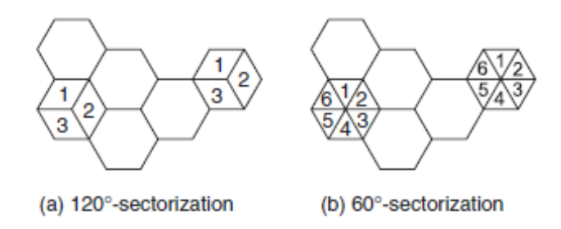
10. Multiple antennas: these can be used to enhance capacity via different scenarios:
(a) diversity (Chapter 13) increases the quality of the received signal, which can be exploited to increase capacity – e.g., by use of higher order modulation formats, or reduction of the reuse distance;
(b) multiple-input multiple-output systems (Section 20.2) increase the capacity of each link;
(c) space division multiple access (Section 20.1) allows several users in the same frequency channel in the same cell to be served.
11. Fractional loading: this system uses a small reuse distance, but uses only a small percentage of the available timeslots in each cell. This leads to approximately the same average capacity as the “conventional” scheme with large reuse distance and full loading of each cell. However, it has higher flexibility, as throughput can be made higher in some cells when throughput in other cells is low.
12. Partial frequency reuse: in this scheme, the available spectrum is divided into N + 1 subbands.One subband is used in all the cell centers, while the other subbands are used at the cell edges,
employing a conventional frequency reuse (with cluster size N). The “cell edges” must be large enough so that interference from one cell center to another is sufficiently weak. We also note that the subbands need not all have the same bandwidth. Depending on the size of the cell center, the subband used in the center might be larger than the bands used at the edges.

UNIT II
PART A
1. What are the three basic propagation mechanisms?
The three basic propagation mechanisms which impact propagation in a mobile communication system are 1.Reflection 2.Diffraction 3.Scattering
2. How diffraction will occur?
Diffraction occurs when the radio path between the transmitter and receiver is obstructed by a surface that has sharp irregularities.
3. What is scattering?
When a radio wave impinges on a rough surface, the reflected energy is spread out in all directions due to scattering.
4. Write the effects of fading.
1. Rapid changes in signal strength over a small travel distance or time interval.
2. Random frequency modulation due to varying Doppler shifts on different multipath signals
3. Time dispersion caused by multipath propagation delays.
5. Define coherence bandwidth.
The coherence bandwidth is related to the specific multipath structure of the channel. The coherence bandwidth is a measure of the maximum frequency difference for which signals are still strongly correlated in amplitude. This bandwidth is inversely proportional to the rms value of time delay spread.
6. What is coherence timer?
It is defined as the required time interval to obtain an envelope correlation of 0.9 or less.
7. Define Doppler shift.
The shift in received signal frequency due to motion is called the Doppler shift.
8. What is Doppler spread?
It is defined as the range of frequencies over which the received Doppler spectrum is essentially non-zero.
9. What are the effects of multipath propagation?
Slow fading and fast fading
10. What is flat fading?
If the mobile radio channel has a constant gain and linear phase response over a bandwidth which is greater than the bandwidth of the transmitted signal, then the received signal will undergo flat fading.
11. Write the conditions for flat fading.
BW of signal<<BW of channel B_{s}<<B_{c}
Symbol period>>Delay spread T_{s}>>¦ơ_{Ʈ}
12. What is frequency selective fading?
If the channel possesses a constant gain and linear phase response over a bandwidth that is, smaller than the bandwidth of transmitted signal, then the channel creates frequency selective fading on the received signal.
13. Write the conditions for frequency selective fading.
BW of signal>BW of channel B_{s} > B_{c}
Symbol period< Delay spread T_{s} < ơ_{Ʈ}
14. Define fast fading channel.
The channel impulse response changes rapidly within the symbol duration. This type of channel is called fast fading channel.
15. Define slow fading channel.
The channel impulse response changes at a rate much slower than the transmitted baseband signal. This type of channel is called slow fading channel.
16. What is meant by time dispersion?
The received signal has a longer duration than that of the transmitted signal, due to the different delays of the signal paths. This is known as time dispersion.
17. What is meant by frequency dispersion?
The received signal has a larger bandwidth than that of the transmitted signal, due to the different Doppler shifts introduced by the components of the multipath. This is known as frequency dispersion.
18. Classify the wireless channels.
Time-flat channels, Frequency -flat channels, Frequency-selective channels
19. What is the need of propagation model?
Propagation models have traditionally focused on predicting the average received signal strength at a given distance from the transmitter, as well as the variability of the signal strength in close spatial proximity to a particular location. Propagation models that predict the mean signal strength for an arbitrary transmitter-receiver separation distance are useful in estimating the radio coverage area of a transmitter.
20. What is free space propagation model?
It is a model which is used to predict received signal strength, when unobstructed line of sight path between transmitter and receiver.
21. What are Fresnel zones?
The concentric circles on the transparent plane located between a transmitter and receiver represent the loci of the origins of secondary wavelets which propagate to the receiver such that the total path length increases by ƛ/2 for successive circles. These circles are called Fresnel zones.
22. Explain knife-edge diffraction model.
Knife edge is the simplest of diffraction models, and the diffraction loss can be readily estimated using the classical Fresnel solution for the field behind the knife edge.
23. What is the need of path loss models in link budget design?
The path loss models are used to estimate the received signal level as the function of distance it becomes possible to predict the SNR for a mobile communication system.
24. Differentiate Flat fading & Frequency selective fading.
Flat Fading Frequency Selective Fading
1. Bandwidth of the signal is lesser than 1.Bandwidth of the signal is greater
the bandwidth of the channel. than the bandwidth of channel.
2. Delay spread is lesser than symbol 2. Delay spread is greater than symbol
period. period.
25. Differentiate Fast fading & slow fading.
Fast Fading Slow Fading
1. High Doppler spread. 1. Low Doppler Spread.
2. Coherence time is lesser than symbol 2. Coherence time is greater than
period. symbol period.
3. Channel variations faster than base band 3. Channel variations slower than base
signal variations. band signal variations.
26. What are the three most important effects due to multipath in mobile radio channel?
Rapid changes in signal strength over a small travel distance or time interval, random frequency modulation due to varying Doppler shifts on different multipath signals.

PART B
- Explain about reflection from dielectrics.
Electromagnetic waves are often reflected at one or more IOs before arriving at the RX. The reflection coefficient of the IO, as well as the direction into which this reflection occurs, determines the power that arrives at the RX position. In this section, we deal with specular reflections. This type of reflection occurs when waves are incident onto smooth, large (compared with the wavelength) objects. A related mechanism is the transmission of waves – i.e., the penetration of waves into and through an IO. Transmission is especially important for wave propagation inside buildings. If the Base Station (BS) is either outside the building, or in a different room, then the waves have to penetrate a wall (dielectric layer) in order to get to the RX. We now derive the reflection and transmission coefficients of a homogeneous plane wave incident onto a dielectric halfspace. The dielectric material is characterized by its dielectric constant ε = ε0εr (where ε0 is the vacuum dielectric constant 8.854 ・ 10−12 Farad/m, and εr is the relative dielectric constant of the material) and conductivity σe. Furthermore, we assume that the material is isotropic and has a relative permeability μr = 1.3 The dielectric constant and conductivity can be merged into a single parameter, the complex dielectric constant:
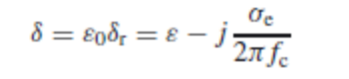
where fc is the carrier frequency, and j is the imaginary unit. Though this definition is strictly valid only for a single frequency, it can actually be used for all narrowband systems, where the bandwidth is much smaller than the carrier frequency, as well as much smaller than the bandwidth over which the quantities σe and ε vary significantly. The plane wave is incident on the halfspace at an angle _e, which is defined as the angle between the wave vector k and the unit vector that is orthogonal to the dielectric boundary. We have to distinguish between the Transversal Magnetic (TM) case, where the magnetic field component is parallel to the boundary between the two dielectrics, and the Transversal Electric (TE) case, where the electric field component is parallel.
The reflection and transmission coefficients can now be computed from postulating incident, reflected, and transmitted plane waves, and enforcing the continuity conditions at the boundary – see, e.g., Ramo et al. [1967]. From these considerations, we obtain Snell’s law: the angle of incidence is the same as the reflected angle:
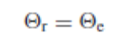
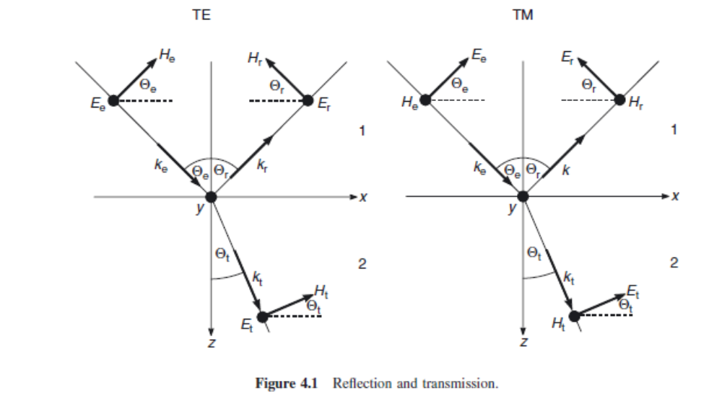
and the angle of the transmitted wave is given by:
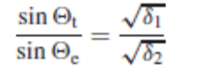
where subscripts 1 and 2 index the considered medium.
The reflection and transmission coefficients are different for TE and for TM waves. For TM polarization:
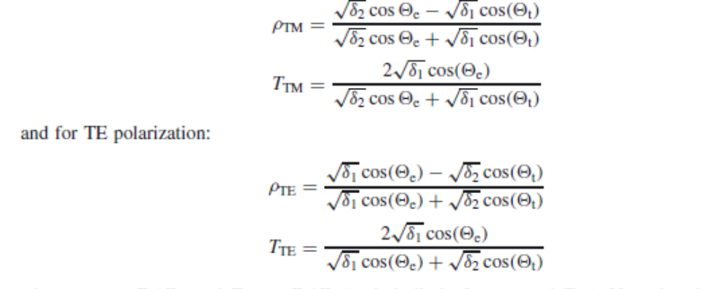
where ρTM = Er/Ee, and TTM = Et/Ee (and similarly for ρTE and TTE). Note that the reflection coefficient has both an amplitude and a phase. Figure 4.2 shows both for a dielectric material with complex dielectric constant δ = 4 − 0.25j . It is noteworthy that for both TE and TM waves, the reflection coefficient becomes −1 (magnitude 1, phase shift of 180◦) at grazing incidence (_e → 90◦). This is the same reflection coefficient that would occur for reflection on an ideally conducting surface. We will see later on that this has important consequences for the impact of ground-reflected waves in wireless systems.
- Explain the knife edge diffraction model by a single screen.
The semi-infinite absorbing screen is a useful tool for the explanation of diffraction, since it is the simplest possible configuration. However, many obstacles especially in urban environments are much better represented by a wedge structure, as sketched in Figure 4.8. The problem of
diffraction by a wedge has been treated for some 100 years, and is still an area of active research.
Depending on the boundary conditions, solutions can be derived that are either valid at arbitrary
observation points or approximate solutions that are only valid in the far field (i.e., far away from the wedge). These latter solutions are usually much simpler, and will thus be the only ones considered 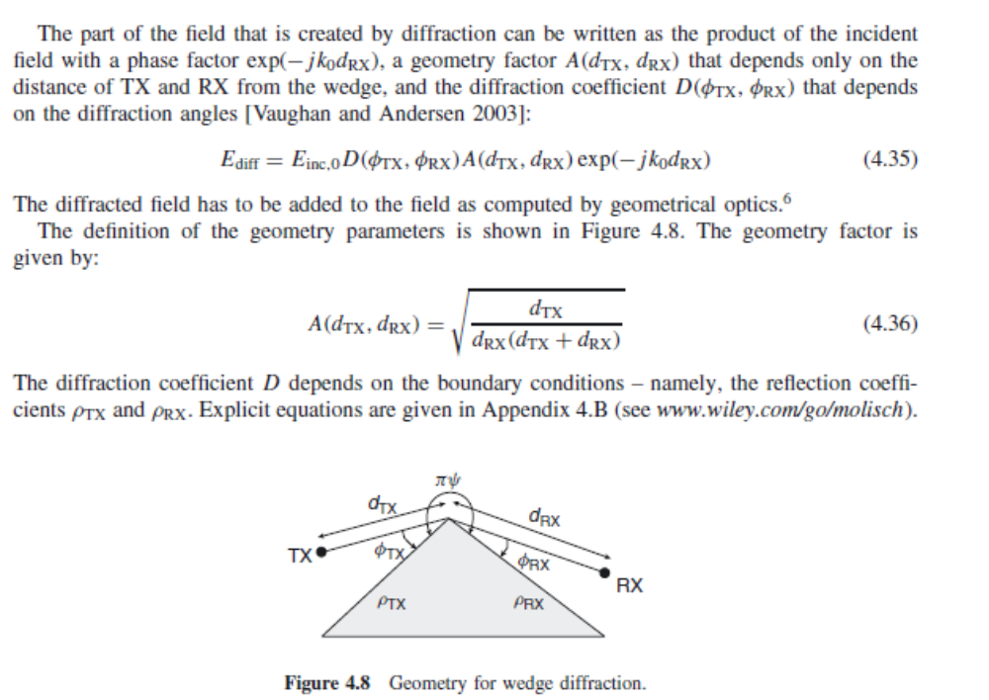
- Explain the different methods of diffraction model by multiple screens.
Diffraction by a single screen is a problem that has been widely studied, because it is amenable to closed-form mathematical treatment, and forms the basis for the treatment of more complex problems. However, in practice, we usually encounter situations where multiple IOs are located between TX and RX. Such a situation occurs, e.g., for propagation over the rooftops of an urban environment. As we see in Figure 4.9, such a situation can be well approximated by diffraction by multiple screens. Unfortunately, diffraction by multiple screens is an extremely challenging mathematical problem, and – except for a few special cases – no exact solutions are available. Still, a wealth of approximate methods has been proposed in the literature, of which we give an overview in the remainder of this section.
Bullington’s Method
Bullington’s method replaces the multiple screens by a single, “equivalent” screen. This equivalent screen is derived in the following way: put a tangential straight line from the TX to the real obstacles, and select the steepest one (i.e., the one with the largest elevation angle), so that all obstacles either touch this tangent, or lie below it. Similarly, take the tangents from the RX to the obstacles, and select the steepest one. The equivalent screen is then determined by the intersection of the steepest TX tangent and the steepest RX tangent (see Figure 4.10). The field resulting from diffraction at this single screen can be computed.
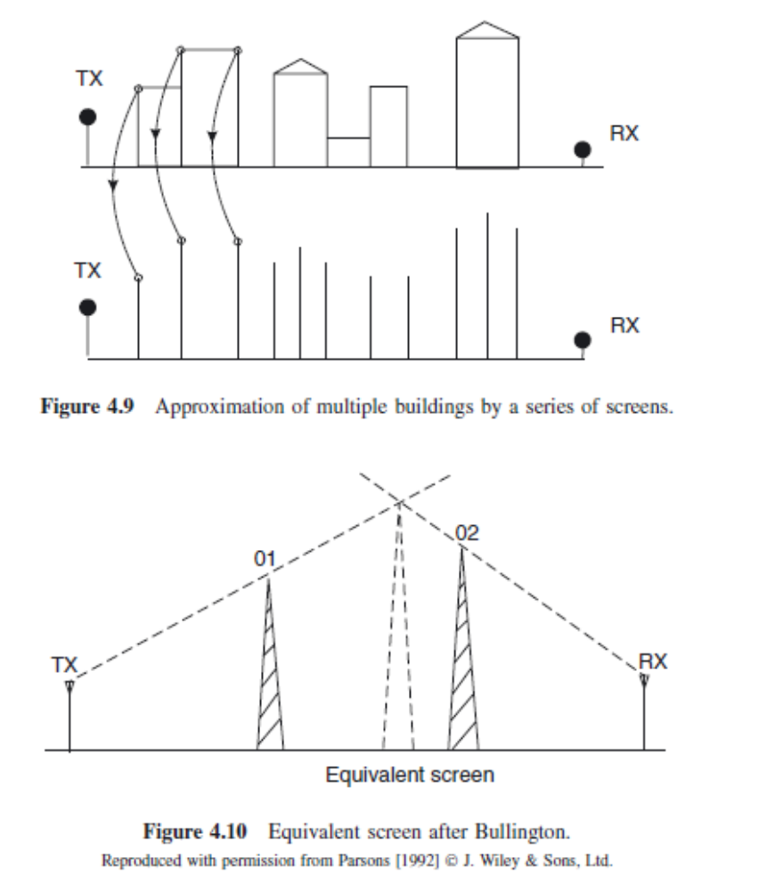
The major attraction of Bullington’s method is its simplicity. However, this simplicity also leads to considerable inaccuracies. Most of the physically existing screens do not impact the location of the equivalent screen. Even the highest obstacle might not have an impact. Consider Figure 4.10: if the highest obstacle lies between screens 01 and 02, it could lie below the tangential lines, and thus not influence the “equivalent” screen, even though it is higher than either screen 01 or screen 02. In reality, these high obstacles do have an effect on propagation loss, and cause an additional attenuation. The Bullington method thus tends to give optimistic predictions of the received power.
The Epstein–Petersen Method
The low accuracy of the Bullington method is due to the fact that only two obstacles determine the equivalent screen, and thus the total diffraction coefficient. This problem can be somewhat mitigated by the Epstein–Petersen method [Epstein and Peterson 1953]. This approach computes the diffraction losses for each screen separately. The attenuation of a specific screen is computed by putting a virtual “TX” and “RX” on the tips of the screens to the left and right of this considered screen (see Figure 4.11). The diffraction coefficient, and the attenuation, of this one screen can be 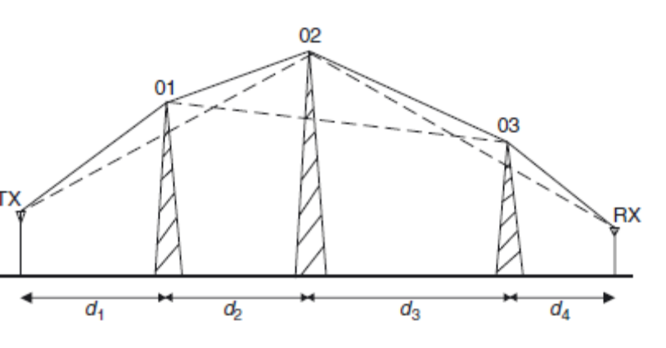
easily computed from the principles of Section 4.3.1. Attenuations by the different screens are then added up (on a logarithmic scale). The method thus includes the effects of all screens. Despite this more refined modeling, the method is still only approximate. It uses the diffraction attenuation (Eq. 4.27) that is based on the assumption that the RX is in the far field of the screen. If, however, two of the screens are close together, this assumption is violated, and significant errors can occur.The inaccuracies caused by this “far-field assumption” can be reduced considerably by the slope diffraction method. In this approach, the field is expanded into a Taylor series. In addition to the zeroth-order term (far field), which enforces continuity of the electrical field at the screen, also the first-order term is taken into account, and used to enforce continuity of the first derivative of the field. This results in modified coefficients A and D, which are determined by recursion equations
Deygout’s Method
The philosophy of Deygout’s method is similar to that of the Epstein–Petersen method, as it also adds up the attenuations caused by each screen [Deygout 1966]. However, the diffraction angles are defined in the Deygout method by a different algorithm:
• In the first step, determine the attenuation between TX and RX if only the ith screen is present (for all i).
• The screen that causes the largest attenuation is defined as the “main screen” – its index is defined as ims.
• Compute the attenuation between the TX and the tip of the main screen caused by the j th screen (with j running now from 1 to ims). The screen resulting in the largest attenuation is called the “subsidiary main screen.” Similarly, compute the attenuation between the main screen and the RX, caused by the j th screen (j >ims + 1).
• Optionally, repeat that procedure to create “subsidiary screens,” etc.
• Add up the losses (in dB) from all considered screens.
The Deygout method works well if there is actually one dominant screen that creates most of the losses. Otherwise, it can create considerable errors.
- Give a detailed note about scattering.
Scattering on rough surfaces (Figure 4.13) is a process that is very important for wireless ommunications. Scattering theory usually assumes roughness to be random. However, in wireless 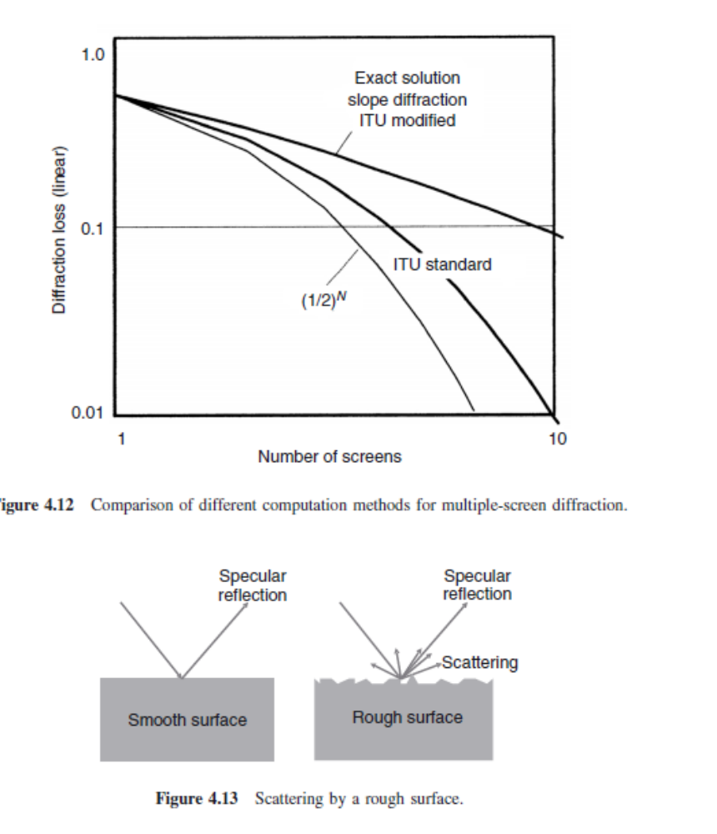
communications it is common to also describe deterministic, possibly periodic, structures (e.g., bookshelves or windowsills) as rough. For ray-tracing predictions (see Section 7.5), “roughness” thus describes all (physically present) objects that are not included in the used maps and building plans. The justifications for this approach are rather heuristic: (i) the errors made are smaller than some other error sources in ray-tracing predictions and (ii) there is no better alternative. That being said, the remainder of this section will consider the mathematical treatment of genuinely rough surfaces. This area has been investigated extensively in the last 30 years, mostly due to its great importance in radar technology. Two main theories have evolved: the Kirchhoff theory and the perturbation theory.
5. Write short notes on i) time-selective channels ii) frequency-selective channels

7. Write short notes on WSSUS channels.
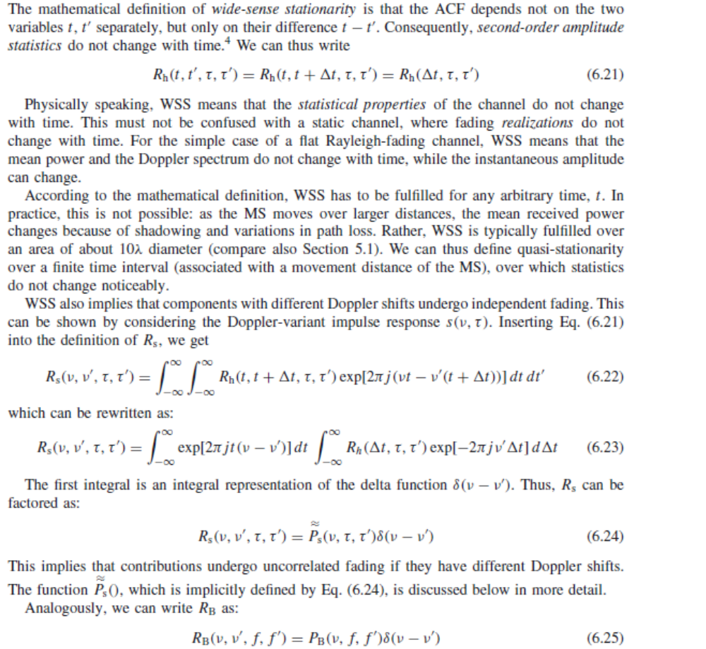
8. Explain Okumura-Hata empirical model in detail.
The Okumura–Hata model is by far the most popular model in that category. Path loss (in dB) is written as PL = A + B log(d) + C
where A, B, and C are factors that depend on frequency and antenna height. Factor A increases with
carrier frequency and decreases with increasing height of the BS and Mobile Station (MS). Also, the path loss exponent (proportional to B) decreases with increasing height of the BS. The model is only intended for large cells, with the BS being placed higher than the surrounding rooftops.
9. Explain the different types of narrowband path-loss models.
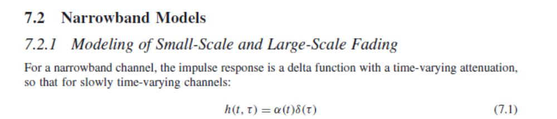

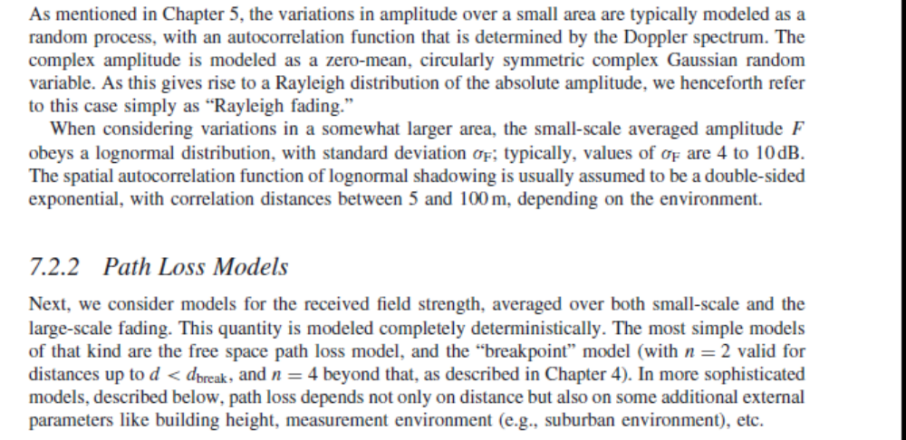

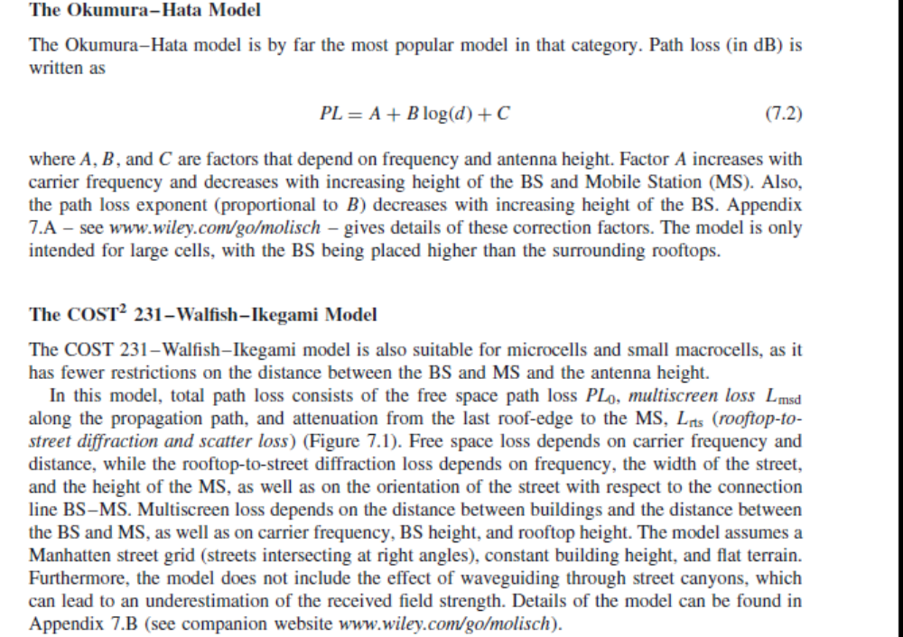

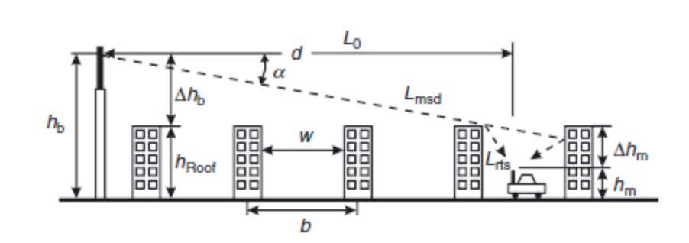

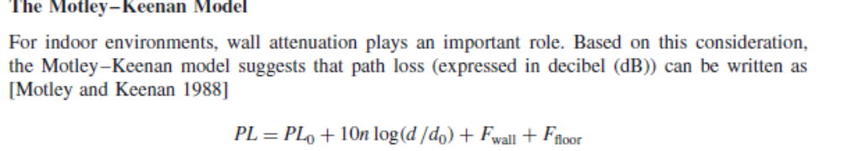
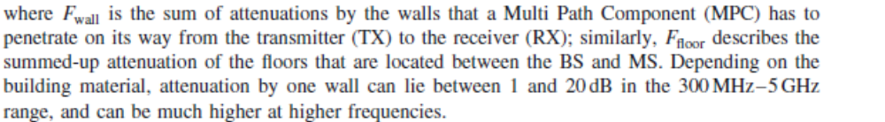
10. Explain the different types of wideband models.
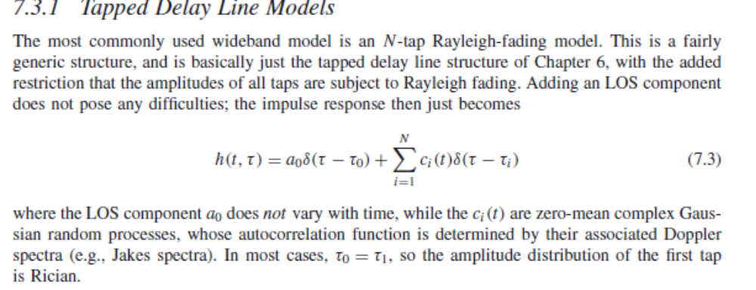
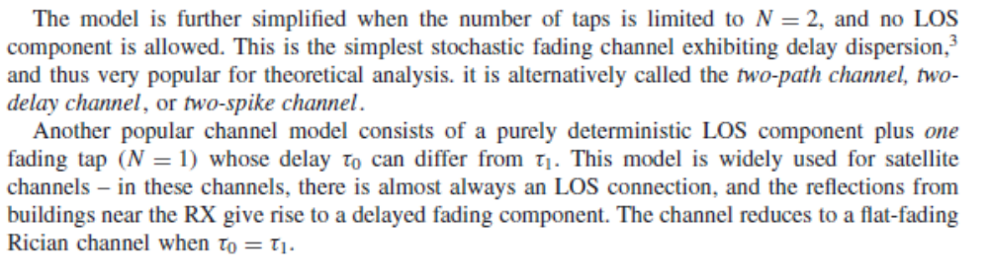
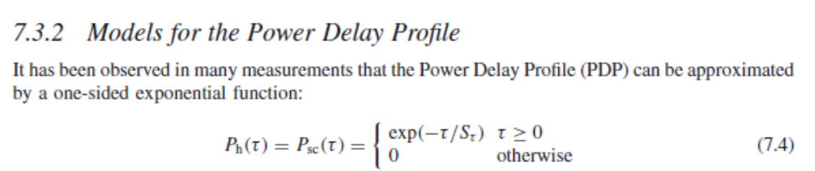
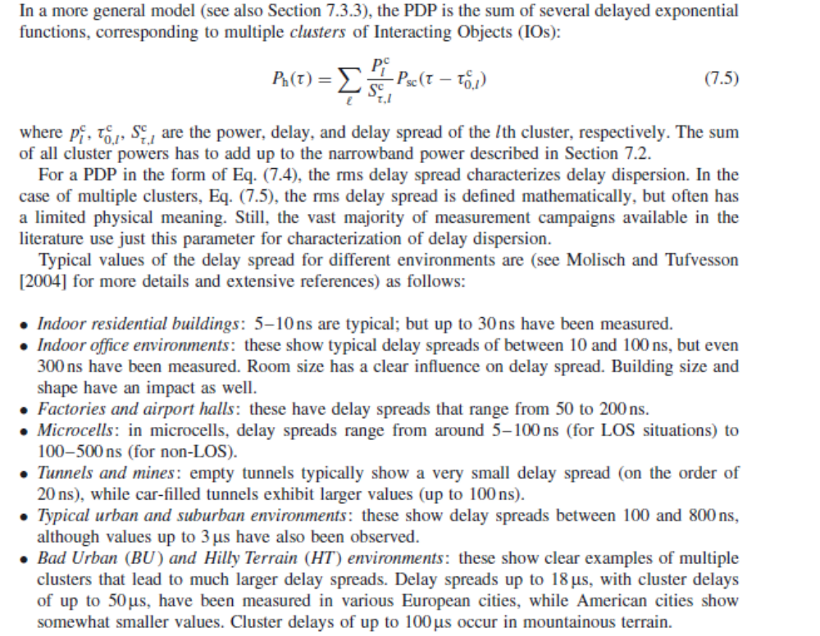

UNIT III
PART A
1. Define modulation.
It is defined as the process by which some parameters of a high frequency signal termed as carrier, is varied in accordance with the signal to be transmitted.
2. What is demodulation?
It is the process of recovering the original modulating signal from a modulated signal.
3. Write the advantages of digital over analog modulation.
Greater noise immunity, Robustness to channel impairments, Easier multiplexing of various forms of information, Greater security
4. What is meant by Amplitude shift keying?
If amplitude of the carrier is varied depending on the incoming digital signal, then it is called Amplitude shift keying.
5. What is meant by Frequency shift keying?
If the frequency of the sinusoidal carrier frequency is varied depending on the incoming digital signal, then it is called Frequency shift keying.
6. What is meant by Phase shift keying?
If phase of the carrier is varied depending on the input digital signal, then it is called phase shift keying.
7. Define M-ary transmission system,
In digital modulation instead of transmitting one bit at a time, two or more bits are transmitted simultaneously. This is called M-ary transmission.
8. What is Quadrature modulation?
Sometimes two or more quadrature carriers are used for modulation. It is called quadrature modulation.
9. Explain the following terms a) Baud rate b) Bit rate
Baud rate: Speed at which symbols are transmittd in a digital communication system, ie., no of symbols/second.
Bit rate: Speed at which data bits is transmitted in a digital communication system, ie no of bits/sec.
10. What is QAM?
At high bit rates, a combination of ASK and PSK is employed in order to minimize the errors in the received data. This method is known as Quadrature amplitude modulation.
11. What is meant by QPSK?
QPSK is a multi level modulation in which four phase shifts are used for representing four different symbols.
12. What is linear modulation?
In linear modulation technique, the amplitude of the transmitted (carrier) signal varies linearly with the modulating digital signal. In general, linear modulation does not have a constant envelope.
13. Write the merits of linear modulation.
Bandwidth efficient, Very attractive for use in wireless communication systems, Accommodate more and more users within a limited spectrum.
14. What is non linear modulation?
In non linear modulation, the amplitude of the carrier is constant regardless of the variation in the modulating signal.
15. Mention the merits and demerits of non linear modulation.
Merits:
1. Lower efficient class c amplifiers can be used without introducing degradation in the spectrum occupancy of the transmitted signal.
2. Low out of band radiation of the order of -60dB to -70dB can be achieved.
3. Limiter-discriminator detection can be used, which simplifies receiver design and provides high immunity against random FM noise and signal fluctuations due to Rayleigh fading.
Demerits:
1. Constant envelope modulations occupy a larger bandwidth than linear modulation scheme
2. In situations where bandwidth efficiency is more important than power efficiency, constant envelope modulation is not well suited.
16. What is the advantage of MSK over QPSK?
In QPSK the phase changes by 90 or 180 degrees. This creates abrupt amplitude variations in the waveform. Therefore bandwidth requirement of QPSK is more. MSK overcomes this problem. In MSK, the output waveform is continuous in phase hence there are no abrupt changes in amplitude.
17. Why MSK is called as fast FSK?
MSK is called fast FSK, as the frequency spacing used is only half as much as that used in conventional non-coherent FSK.
18. Mention some merits of MSK.
Constant envelope, Spectral efficiency, Good BER performance, Self-synchronizing capability
19. Why MSK cannot be directly used in multi user communications?
1. The main lobe of MSK is wide. This makes MSK unsuitable for the applications where extremely narrow bandwidths and sharp cut-offs are required.
2. Slow decay of MSK power spectral density curve creates adjacent channel interference. Hence MSK cannot be used for multiuser communications.
20. What is the need of Gaussian filter?
Gaussian filters used before the modulator to reduce the transmitted bandwidth of the signal. It uses less bandwidth than conventional FSK.
21. Give some examples of linear modulation.
Pulse shaped QPSK, OQPSK, π/4QPSK
22. Give some examples for constant envelope modulation.
BFSK, MSK, GMSK
23. Define QAM.
Quadrature amplitude modulation is in which both the amplitude and phase of the transmitted signals are varied by the baseband signal.
24. Define M-ary FSK.
In M-ary system, M=2N different symbols are used and N no of bits per symbol. Every symbol uses separate frequency for transmission.
25. Write the applications of MFSK and OFDM.
They are used for high speed data connections as part of the IEEE 802.11a standards activities to provide 54mbps WLAN connections, as well as for high speed line of sight and non line of sight connections for Multi channel Multipoint Distribution service (MMDS) operation.
26. What are the modulations suitable for frequency selective mobile channels?
Both filtered and unfiltered BPSK, QPSK, OQPSK and MSK modulations are suitable for frequency selective mobile channels.
PART B
- Explain digital modulation transmitter and receiver with neat block diagram.
Figures show a more detailed block diagram of a digital TX and RX that concentrate on the hardware aspects and the interfaces between analog and digital components:
• The information source provides an analog source signal and feeds it into the source ADC (Analog to Digital Converter). This ADC first band limits the signal from the analog information source (if necessary), and then converts the signal into a stream of digital data at a certain sampling rate and resolution (number of bits per sample). For example, speech would typically be sampled at 8 ksamples/s, with 8-bit resolution, resulting in a datastream at 64 kbit/s. For the transmission of digital data, these steps can be omitted, and the digital source directly provides the input to interface “G” in Figure .
• The source coder uses a priori information on the properties of the source data in order to reduce redundancy in the source signal. This reduces the amount of source data to be transmitted, and thus the required transmission time and/or bandwidth. For example, the Global System for Mobile communications (GSM) speech coder reduces the source data rate from 64 kbit/s mentioned above to 13 kbit/s. Similar reductions are possible for music and video (MPEG standards). Also, fax information can be compressed significantly. One thousand subsequent symbols “00” (representing “white” color), which have to be represented by 2,000 bits, can be replaced by the statement: “what follows now are 1,000 symbols 00,” which requires only 12 bits. For a typical fax, compression by a factor of 10 can be achieved. The source coder increases the entropy (information per bit) of the data at interface F; as a consequence, bit errors have greater impact. For some applications, source data are encrypted in order to prevent unauthorized listening in.
• The channel coder adds redundancy in order to protect data against transmission errors. This increases the data rate that has to be transmitted at interface E – e.g., GSM channel coding increases the data rate from 13 to 22.8 kbit/s. Channel coders often use information about the statistics of error sources in the channel (noise power, interference statistics) to design codes that are especially well suited for certain types of channels (e.g., Reed–Solomon codes protect especially well against burst errors). Data can be sorted according to importance; more important bits then get stronger protection. Furthermore, it is possible to use interleaving to break up error bursts; note that interleaving is mainly effective if it is combined with channel coding.
• Signaling adds control information for the establishing and ending of connections, for associating information with the correct users, synchronization, etc. Signaling information is usually strongly protected by error correction codes.
• The multiplexer combines user data and signaling information, and combines the data from multiple users.2 If this is done by time multiplexing, the multiplexing requires some time compression.
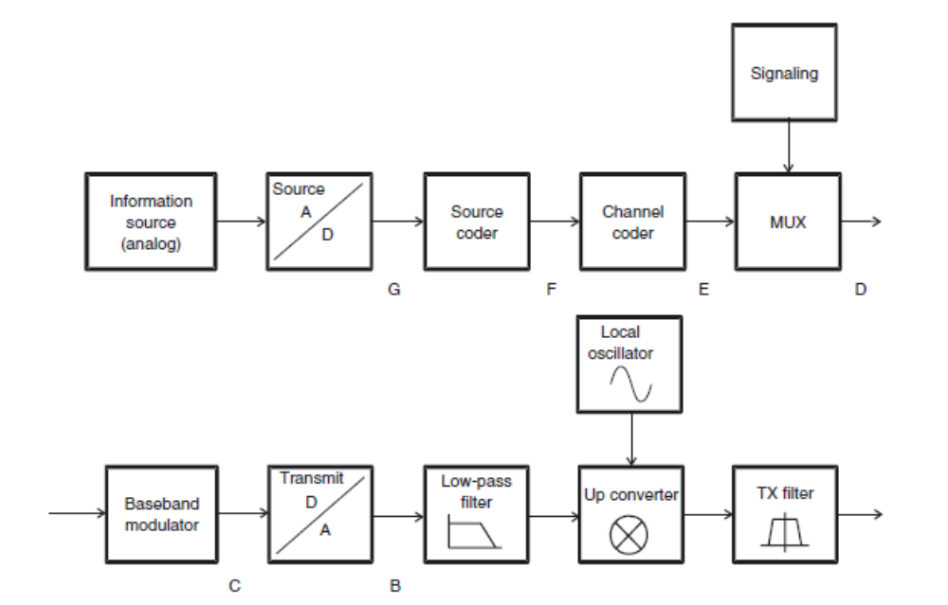
In GSM, multiaccess multiplexing increases the data rate from 22.8 to 182.4 kbit/s (8 · 22.8) for the standard case of eight participants. The addition of signaling information increases the data rate to 271 kbit/s.
• The baseband modulator assigns the gross data bits (user data and signaling at interface D) to complex transmit symbols in the baseband. Spectral properties, intersymbol interference, peakto-average ratio, and other properties of the transmit signal are determined by this step. The output from the baseband modulator (interface C) provides the transmit symbols in oversampled form, discrete in time and amplitude. Oversampling and quantization determine the aliasing and quantization noise. Therefore, high resolution is desirable, and the data rate at the output of the baseband modulator should be much higher than at the input. For a GSM system, an oversampling factor of 16 and 8-bit amplitude resolution result in a data rate of about 70 Mbit/s.
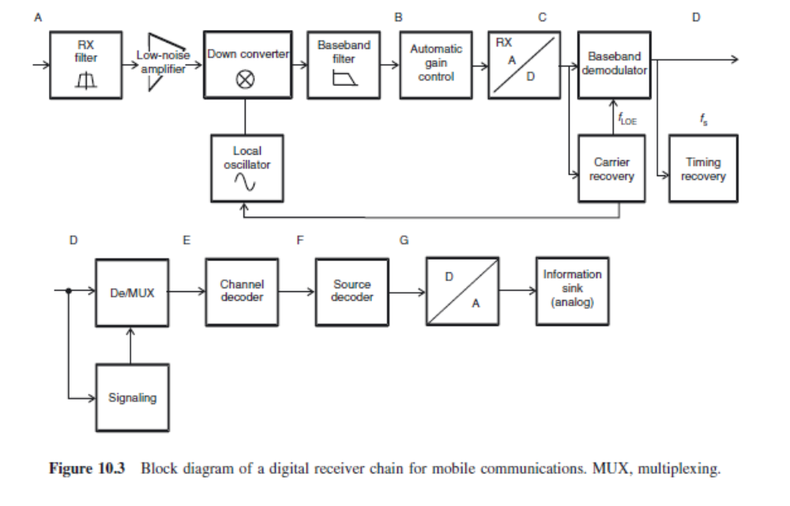
• The TX Digital to Analog Converter (DAC) generates a pair of analog, discrete amplitude voltages corresponding to the real and imaginary part of the transmit symbols, respectively.
• The analog low-pass filter in the TX eliminates the (inevitable) spectral components outside the desired transmission bandwidth. These components are created by the out-of-band emission of an (ideal) baseband modulator, which stem from the properties of the chosen modulation format. Furthermore, imperfections of the baseband modulator and imperfections of the DAC lead to additional spurious emissions that have to be suppressed by the TX filter.
• The TX Local Oscillator (LO) provides an unmodulated sinusoidal signal, corresponding to one of the admissible center frequencies of the considered system. The requirements for frequency stability, phase noise, and switching speed between different frequencies depend on the modulation and multiaccess method.
• The upconverter converts the analog, filtered baseband signal to a passband signal by mixing it with the LO signal. Upconversion can occur in a single step, or in several steps. Finally, amplification in the Radio Frequency (RF) domain is required.
• The RF TX filter eliminates out-of-band emissions in the RF domain. Even if the low-pass filter succeeded in eliminating all out-of-band emissions, upconversion can lead to the creation of additional out-of-band components. Especially, nonlinearities of mixers and amplifiers lead to intermodulation products and “spectral regrowth” – i.e., creation of additional out-of-band emissions. The (analog) propagation channel attenuates the signal, and leads to delay and frequency dispersion. Furthermore, the environment adds noise (Additive White Gaussian Noise – WGN) and co-channel interference.
• The RX filter performs a rough selection of the received band. The bandwidth of the filter corresponds to the total bandwidth assigned to a specific service, and can thus cover multiple communications channels belonging to the same service.
• The low-noise amplifier amplifies the signal, so that the noise added by later components of the RX chain has less effect on the Signal-to-Noise Ratio (SNR). Further amplification occurs in the subsequent steps of downconversion.
• The RX LO provides sinusoidal signals corresponding to possible signals at the TX LO. The frequency of the LO can be fine-tuned by a carrier recovery algorithm (see below), to make sure that the LOs at the TX and the RX produce oscillations with the same frequency and phase.
• The RX downconverter converts the received signal (in one or several steps) into baseband. In baseband, the signal is thus available as a complex analog signal.
• The RX low-pass filter provides a selection of desired frequency bands for one specific user (in contrast to the RX bandpass filter that selects the frequency range in which the service operates). It eliminates adjacent channel interference as well as noise. The filter should influence the desired signal as little as possible.
• The Automatic Gain Control (AGC) amplifies the signal such that its level is well adjusted to the quantization at the subsequent ADC.
• The RX ADC converts the analog signal into values that are discrete in time and amplitude. The required resolution of the ADC is determined essentially by the dynamics of the subsequent signal processing. The sampling rate is of limited importance as long as the conditions of the sampling theorem are fulfilled. Oversampling increases the requirements for the ADC, but simplifies subsequent signal processing.
• Carrier recovery determines the frequency and phase of the carrier of the received signal, and uses it to adjust the RX LO.
• The baseband demodulator obtains soft-decision data from digitized baseband data, and hands them over to the decoder. The baseband demodulator can be an optimum, coherent demodulator, or a simpler differential or incoherent demodulator. This stage can also include further signal processing like equalization.
• If there are multiple antennas, then the RX either selects the signal from one of them for further processing or the signals from all of the antennas have to be processed (filtering, amplification, downconversion). In the latter case, those baseband signals are then either combined before being fed into a conventional baseband demodulator or they are fed directly into a “joint” demodulator that can make use of information from the different antenna elements.
• Symbol-timing recovery uses demodulated data to determine an estimate of the duration of symbols, and uses it to fine-tune sampling intervals.
• The decoder uses soft estimates from the demodulator to find the original (digital) source data.In the most simple case of an uncoded system, the decoder is just a hard-decision (threshold) device. For convolutional codes, Maximum Likelihood Sequence Estimators (MLSEs, such as the Viterbi decoder) are used. Recently, iterative RXs that perform joint demodulation and decoding have been proposed. Remaining errors are either taken care of by repetition of a data packet (Automatic Repeat reQuest – ARQ) or are ignored. Signaling recovery identifies the parts of the data that represent signaling information and controls the subsequent demultiplexer.
• The demultiplexer separates the user data and signaling information and reverses possible time compression of the TX multiplexer. Note that the demultiplexer can also be placed earlier in the transmission scheme; its optimum placement depends on the specific multiplexing and multiaccess scheme.
• The source decoder reconstructs the source signal from the rules of source coding. If the source data are digital, the output signal is transferred to the data sink. Otherwise, the data are transferred to the DAC, which converts the transmitted information into an analog signal, and hands it over to the information sink.
- Explain QPSK transmitter and receiver with signal space diagram and give an expression for spectral efficiency.
A Quadrature-Phase Shift Keying (QPSK)-modulated signal is a PAM where the signal carries 1 bit per symbol interval on both the in-phase and quadrature-phase component. The original data stream is split into two streams, b1i and b2i :b1i = b2i b2i = b2i+1
each of which has a data rate that is half that of the original data stream: RS = 1/TS = RB/2 = 1/(2TB) Let us first consider the situation where basis pulses are rectangular pulses, g(t ) = gR(t, TS).
Then we can give an interpretation of QPSK as either a phase modulation or as a PAM. We first define two sequences of pulses 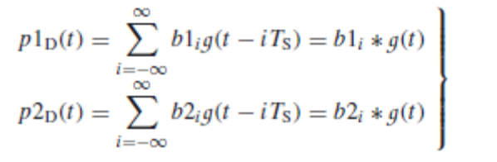
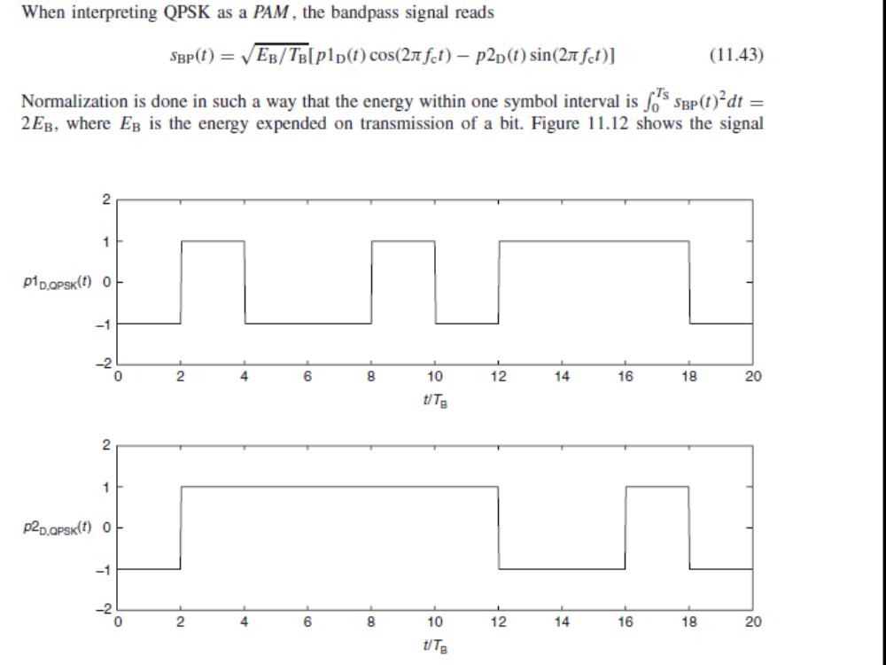

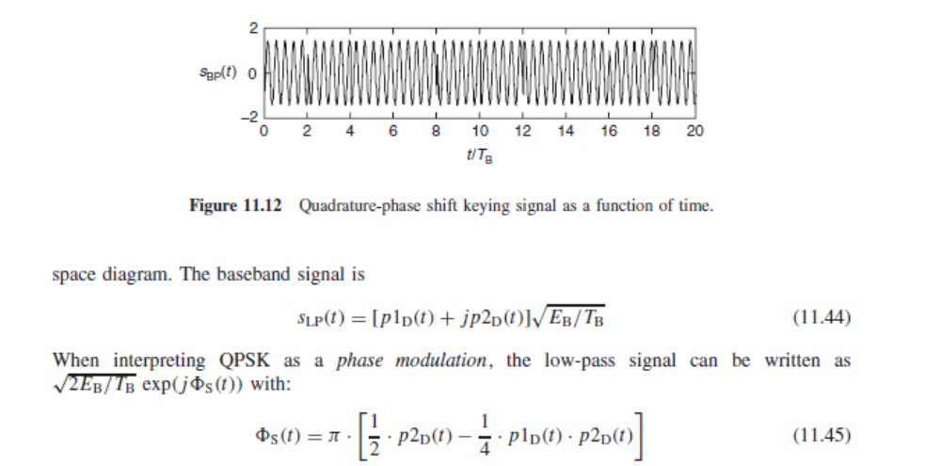
- Explain π/4QPSK transmitter and receiver with signal space diagram and give an expression for spectral efficiency.
Even though QPSK is nominally a constant envelope format, it has amplitude dips at bit ransitions; this can also be seen by the fact that the trajectories in the I–Q diagram pass through the origin for 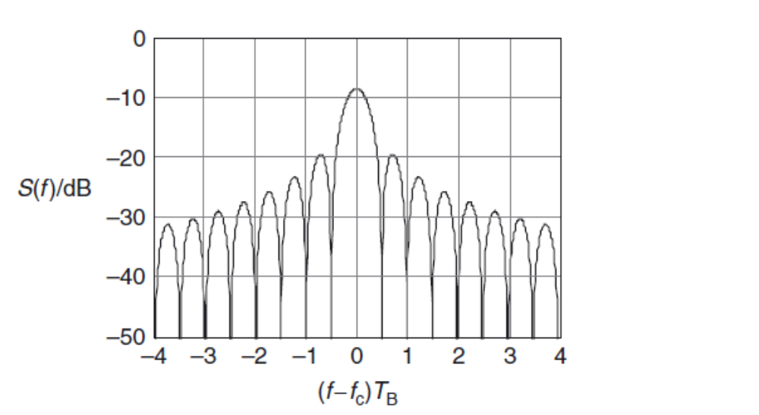
some of the bit transitions. The duration of the dips is longer when non-rectangular basis pulses are used. Such variations of the signal envelope are undesirable, because they make the design of suitable amplifiers more difficult. One possibility for reducing these problems lies in the use of π/4-DQPSK (π/4 differential quadrature-phase shift keying). This modulation format had great importance for second-generation cellphones – it was used in several American standards (IS-54, IS-136, PWT), as well as the Japanese cellphone (JDC) and cordless (PHS) standards, and the European trunk radio standard (TETRA).
The principle of π/4-DQPSK can be understood from the signal space diagram of DQPSK (see Figure 11.18).
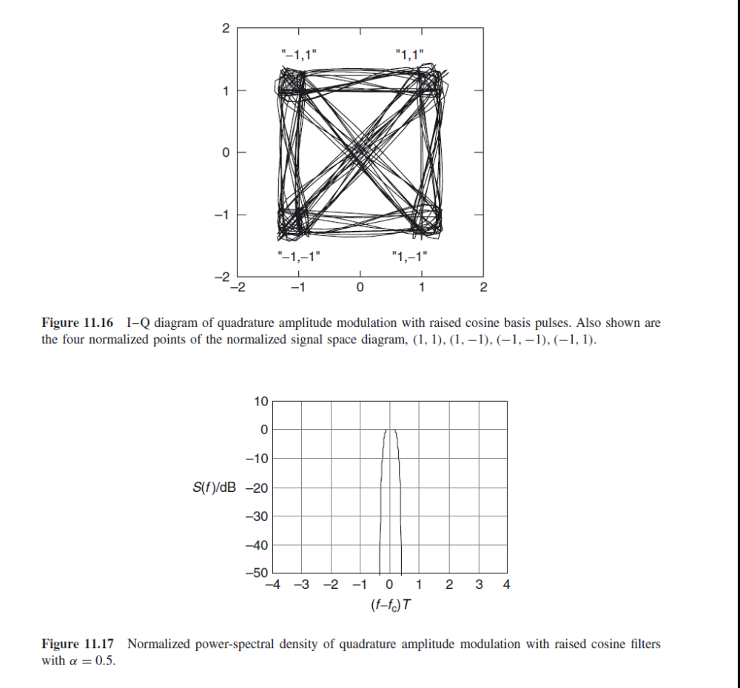

There exist two sets of signal constellations: (0, 90, 180, 270◦) and (45, 135, 225 , 315◦). All symbols with an even temporal index i are chosen from the first set, while all symbols with odd index are chosen from the second set. In other words: whenever t is an integer multiple f
the symbol duration, the transmit phase is increased by π/4, in addition to the change of phase due to the transmit symbol. Therefore, transitions between subsequent signal constellations can never pass through the origin (see Figure 11.19); in physical terms, this means smaller fluctuations of the envelope.
The signal phase is given by
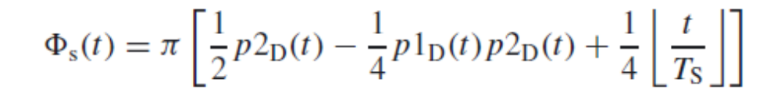
where x denotes the largest integer smaller or equal to x. Comparing this with Eq. (11.45), we can
clearly see the change in phase at each integer multiple of TS.
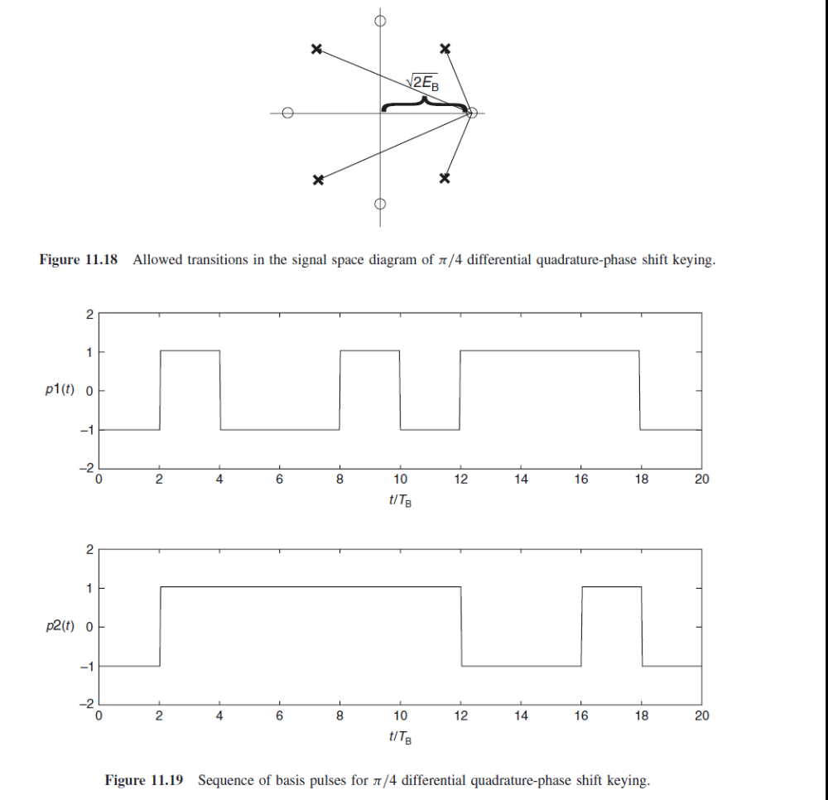

- Explain offset QPSK transmitter and receiver with signal space diagram and give an expression for spectral efficiency. 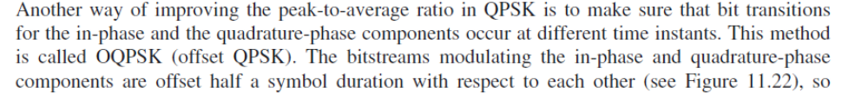
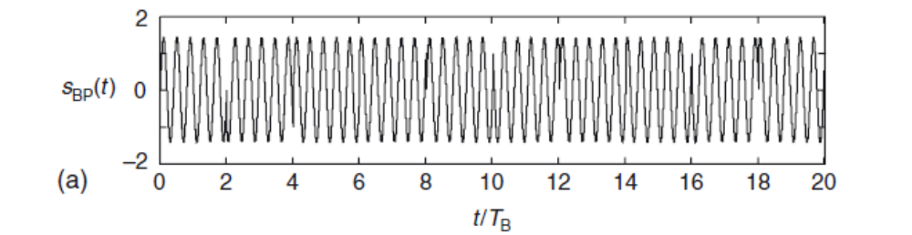
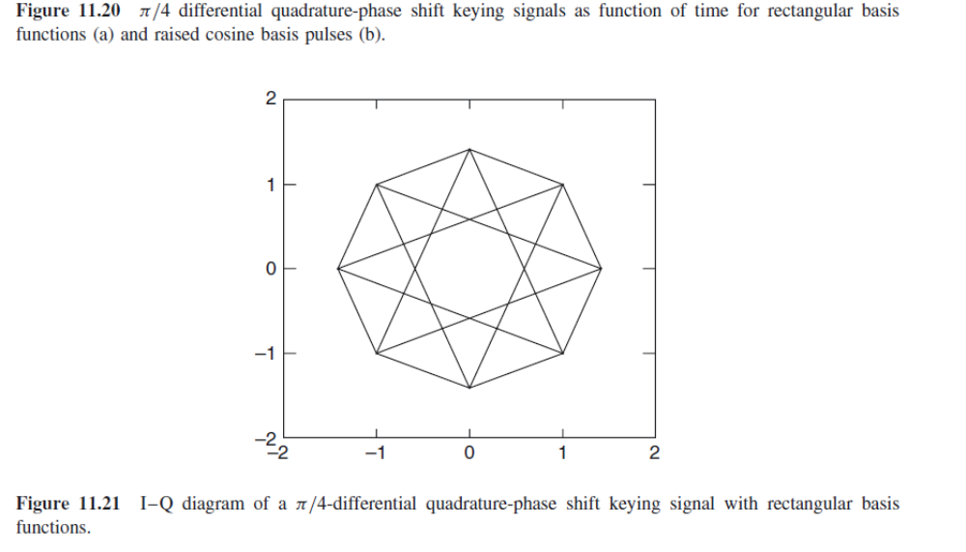
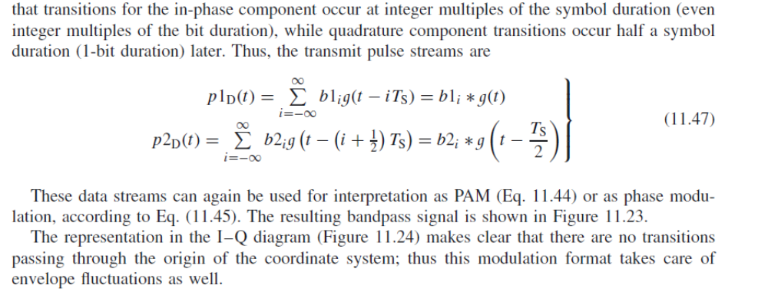
- Explain BFSK transmitter and receiver with signal space diagram and give an expression for spectral efficiency.
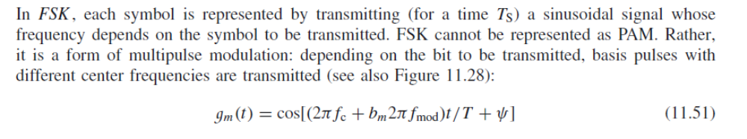
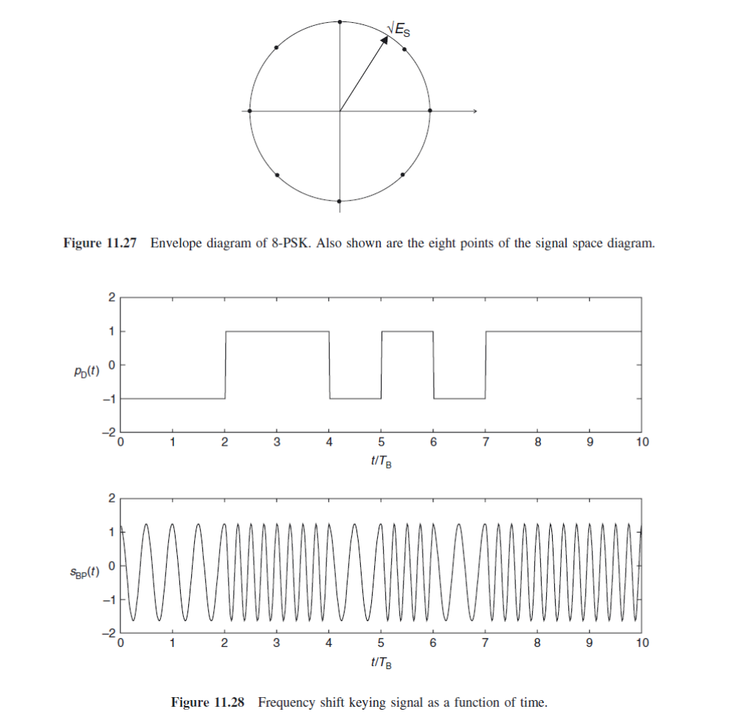
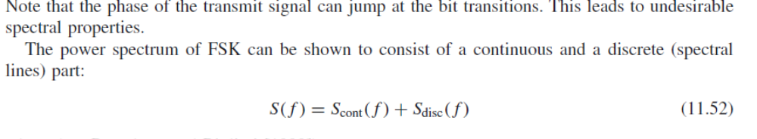
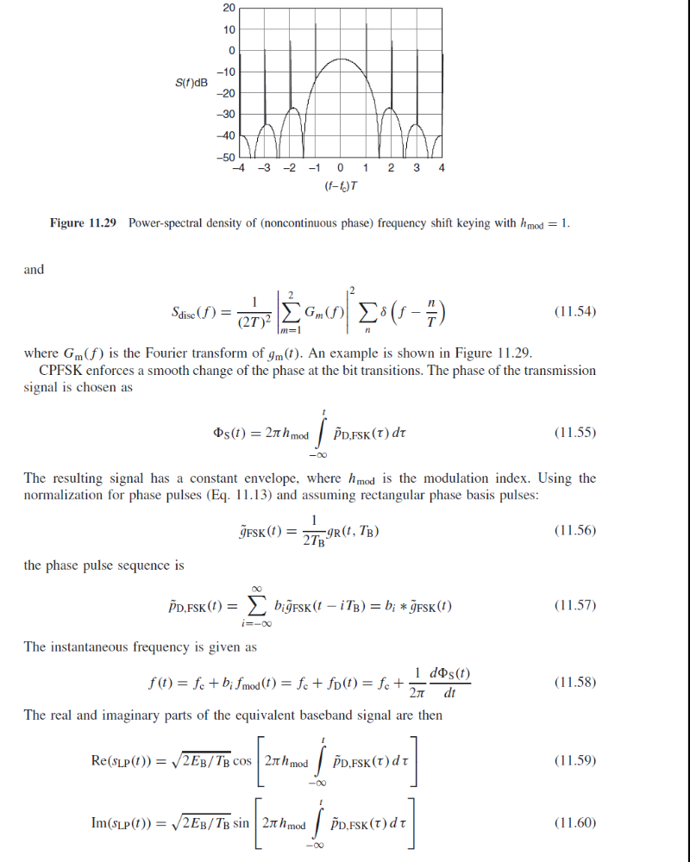
- Explain MSK transmitter and receiver with signal space diagram and give an expression for spectral efficiency.
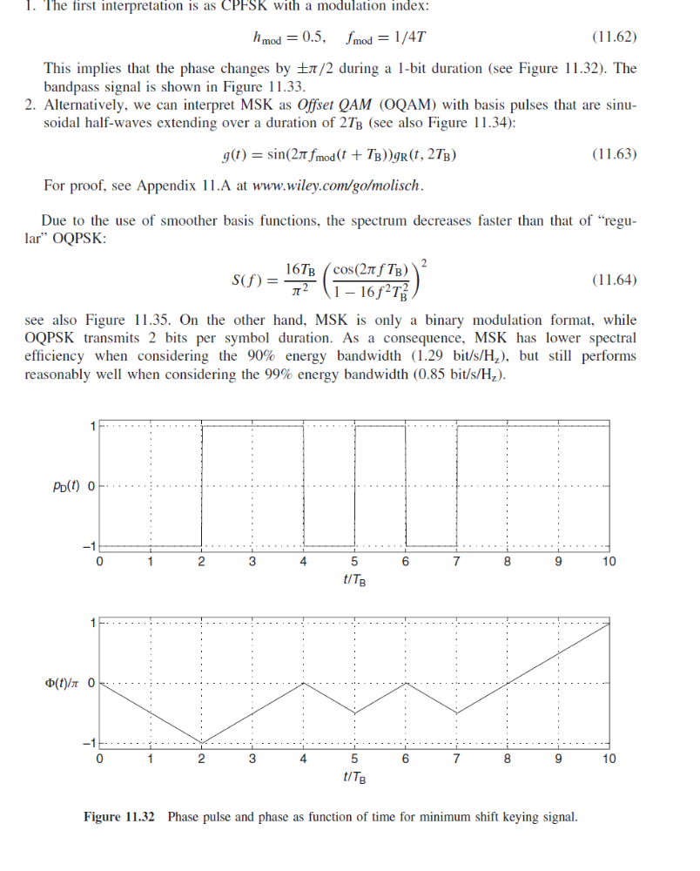
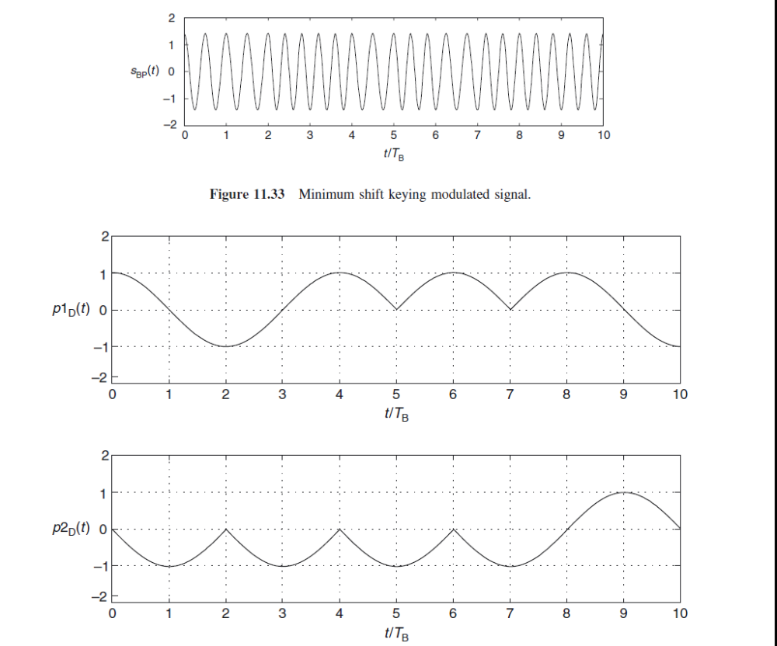
- Explain GMSK transmitter and receiver with signal space diagram and give an expression for spectral efficiency.
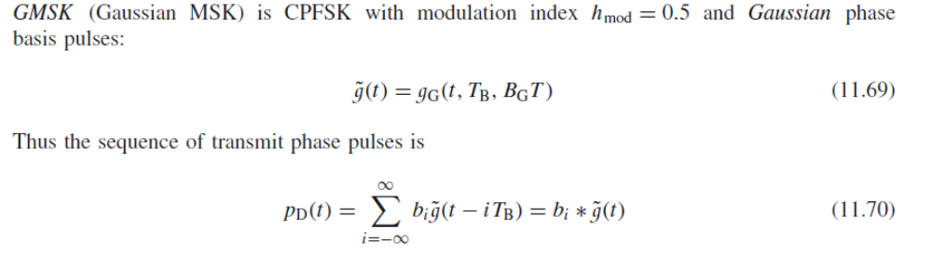
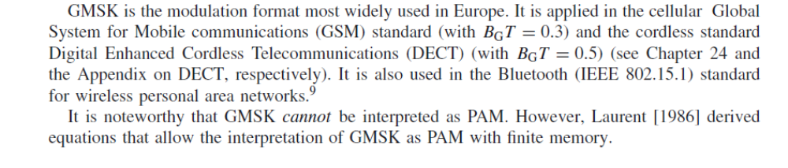
- Discuss about the performance of digital modulation in fading channels.
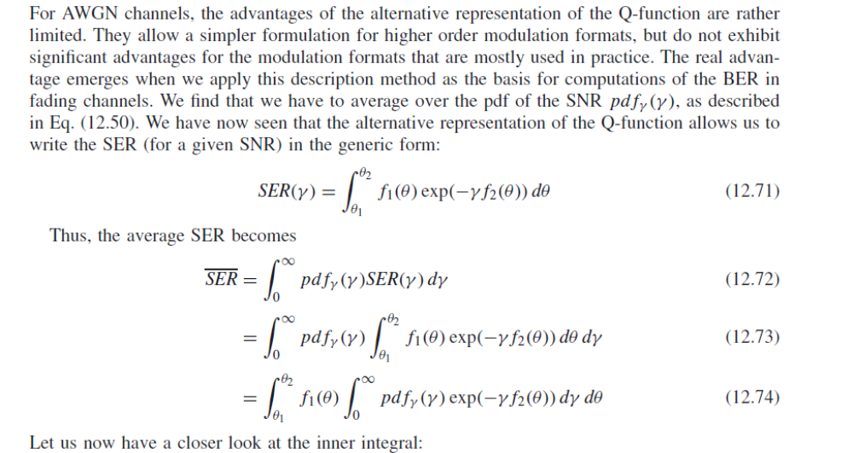
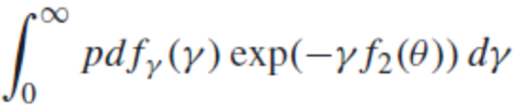
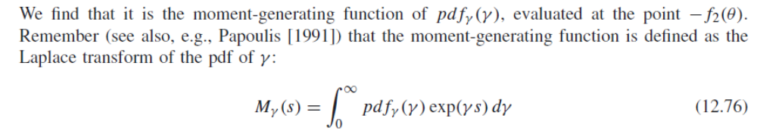
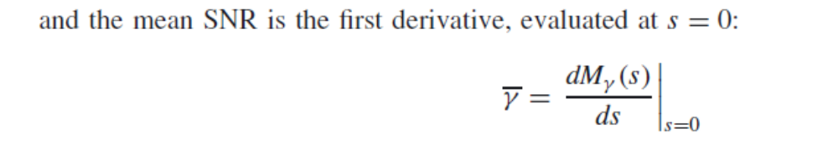

UNIT IV
PART A
1. What are the techniques used to improve the received signal quality?
Equalization, Diversity and Channel coding
2. What is the need of equalization?
Equalization is used to compensate the inter-symbol interference created by multipath within time dispersion channel.
3. Write the functions of diversity.
Diversity is used to compensate for fading channel impairments, and is usually implemented by using two or more receiving antennas.
Diversity improves transmission performance by making use of more than one independently faded version of the transmitted signal.
4. Define spatial diversity.
The most common diversity technique is called spatial diversity, whereby multiple antennas are strategically spaced and connected to a common receiving system. While one antenna sees a signal null, one of the other antennas may see a signal peak, and the receiver is able to select the antenna with the best signals at any time.
5. What is the function of channel coding?
Channel coding is used by the receiver to detect or correct some of the errors introduced by the channel in a particular sequence of message bits.
6. Write the examples of channel coding.
Block codes, Convolution codes and Turbo codes
7. What is equalizer?
The device which equalizes the dispersive effect of a channel is referred to as an equalizer.
8. Define adaptive equalizer.
To combat ISI, the equalizer coefficients should change according to the channel status so as to track the channel variations. Such an equalizer is called an adaptive equalizer since it adapts to the channel variations.
9. What are the operating modes available in an adaptive equalizer?
Training and tracking modes.
10. What is training mode in an adaptive equalizer?
First, a known fixed length training sequence is sent by the transmitter, then the receiver's equalizer may adapt to a proper setting of minimum bit error rate detection, where the training sequence is pseudorandom binary signal or a fixed and prescribed bit pattern.
11. What is tracking mode in an adaptive equalizer?
Immediately following the training sequence, the user data is sent, and the adaptive equalizer at the receiver utilizes a recursive algorithm to evaluate the channel and estimate filter coefficients to compensate for the distortion created by multipath in the channel.
12. Write a short note on i)linear equalizers ii)non-linear equalizers
If the output is not used in the feedback path to adapt, then this type of equalizer is called linear equalizer. If the output is fed back to change the subsequent outputs of the equalizer, this type of equalizer is called non linear equalizers.
13. Write the advantages of lattice equalizer.
It is simplest and easily available, Numerical stability, Faster convergence, Unique structure of the lattice filter allows the dynamic assignment of the most effective length of the lattice equalizer and When the channel becomes more time dispersive, the length of the equalizer can be increased by the algorithm without stopping the operation of the equalizer.
14. Mention the disadvantages of lattice equalizer.
1. If the channel is not very time dispersive, only a fraction of stages are used.
2. It is more complicated than a linear transversal equalizer.
15. Why nonlinear equalizers are preferred?
The linear equalizers are very effective in equalizing channels where ISI is not severe. The severity of ISI is directly related to the spectral characteristics. In this case there are spectrel nulls in the transfer function of the effective channel, the additive noise at the receiver input will be dramatically enhanced by the linear equalizer. To overcome this problem, non linear equalizers can be used.
16. What are the nonlinear equalization methods used?
Decision feedback equalization (DFE), Maximum likelihood symbol detection and Maximum likelihood sequence estimation (MLSE).
17. Where DFEs are used?
DFE is particularly useful for channels with severe amplitude distortions and is widely used in wireless communications.
18. What are the factors used in adaptive algorithms?
Rate of convergence, Misadjustment, Computational complexity and numerical properties.
19. Define rate of convergence.
The no of iterations required for the algorithm in response to stationary inputs to converge close enough to the optimum solution.
20. Write the basic algorithms used for adaptive equalization.
Zero forcing algorithm (ZF), least mean square algorithm (LMS) and recursive least square algorithm (RLS).
21. Write the advantages of LMS algorithm.
It maximizes the signal to distortion at its output within the constraints of the equalizer filter length, Low computational complexity and Simple program
22. Write the advantages of RLS algorithm.
Fast convergence, Good tracking ability
23. Explain Diversity concept.
If one radio path undergoes a deep fade, another independent path may have a strong signal. By having more than one path to select from, both the instantaneous and average SNRs at the receiver may be improved.
24. List out the types of Diversity.
Space diversity, Polarization diversity, Time diversity, Frequency diversity
25. What is the need for diversity schemes?
To increase signal to noise ratio, For error free digital transmission, To degrade the bit error probability.
26. What are the two main classifications of diversity techniques?
Microscopic diversity and Macroscopic diversity
27. List out the four types of Combining Methods.
Selection combining, switched combining, Equal gain combining, Maximum ratio combining
28. What are the major classifications of speech coders?
1. waveform coders 2.vocoder
29. Define waveform coders.
Waveform coders are used to reproduce the time waveform of the speech signal as closely as possible. They are designed to be source dependent.
30. Define vocoders.
Vocoder is a circuit used for digitizing voice at a low data rate by using knowledge of the way in which voice sounds are produced. A vocoder is an example of lossy compression applied to human speech.
31. Write the advantages of vocoders.
It achieves very high economy in transmission bit rate, Less robust.
32. What are the types of vocoders available?
Linear Predictive coder, Channel vocoders, formant vocoders, cepstrum vocoders and voice-excited vocoders.
PART B
- Explain the classification of equalizers.
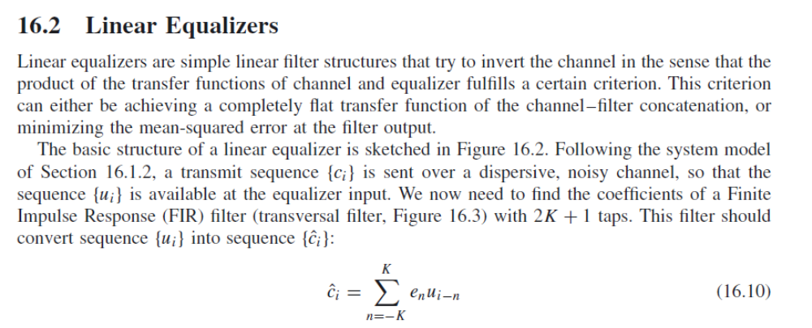
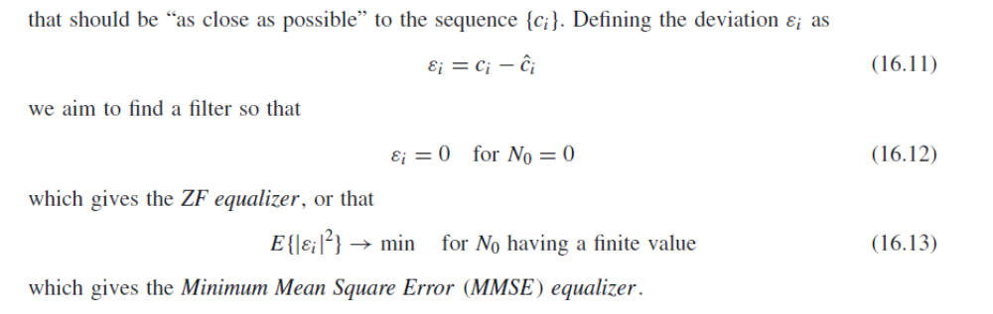
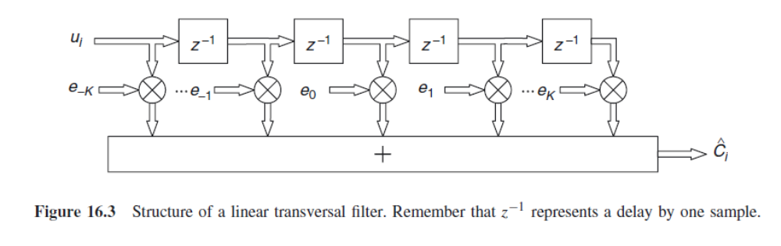
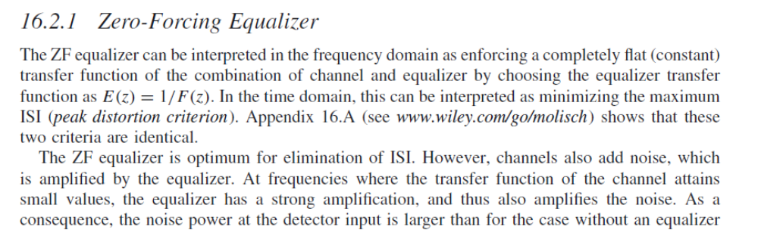
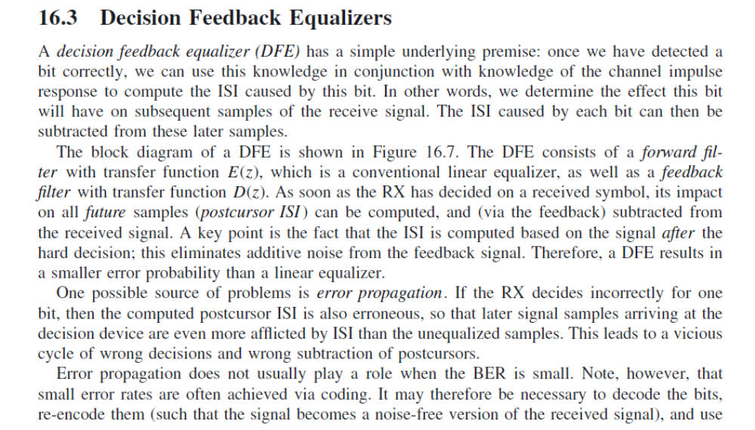
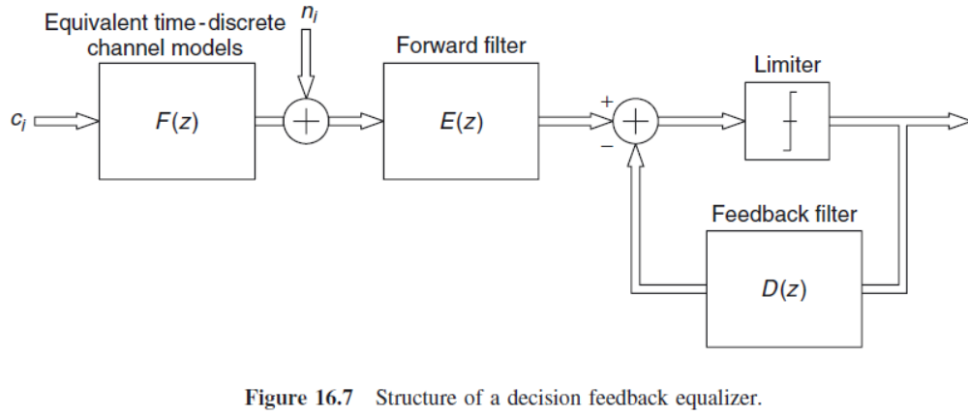
- Briefly explain about linear equalizers.
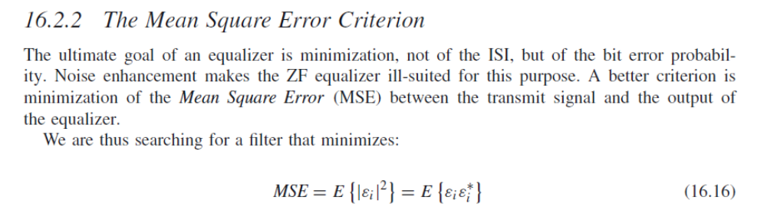
3. Discuss about DFE.
- Explain about MMSE equalizer.
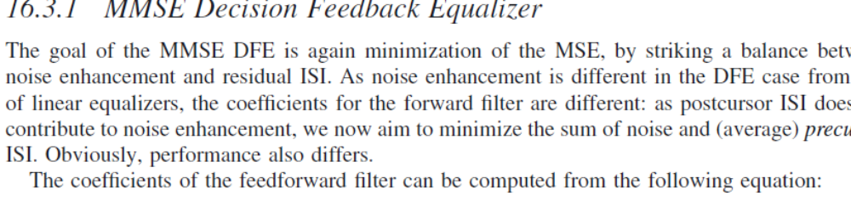
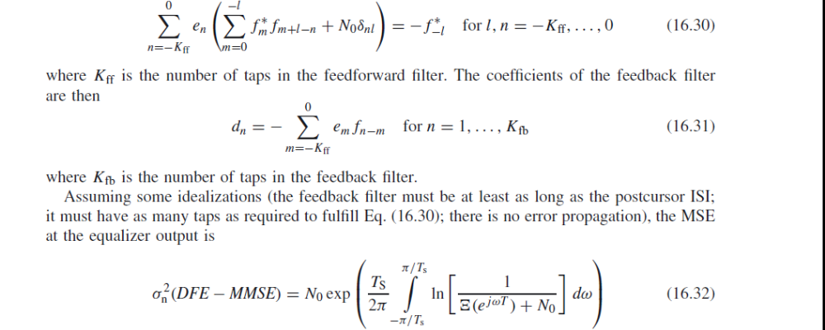
5. Discuss about the performance factors of an adaptive algorithm.
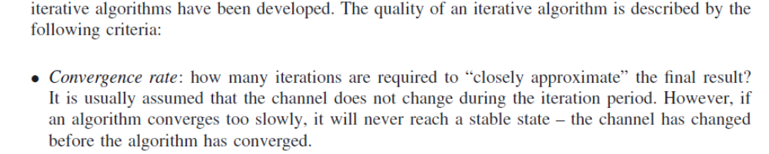
6. Explain LMS algorithm in detail.
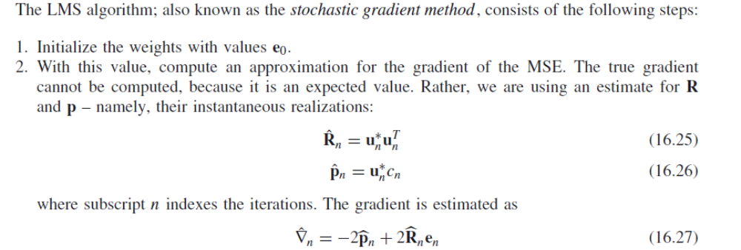
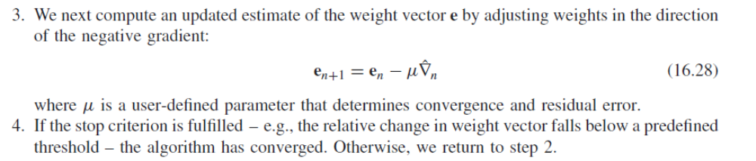
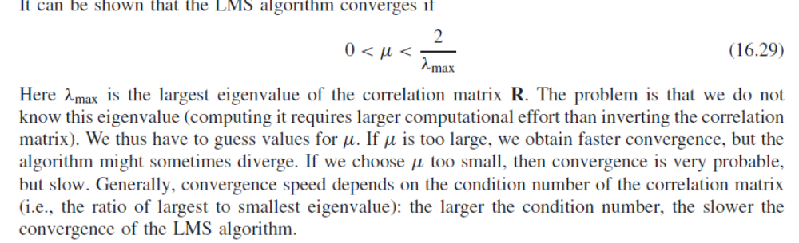
7. Explain RLS algorithm in detail.
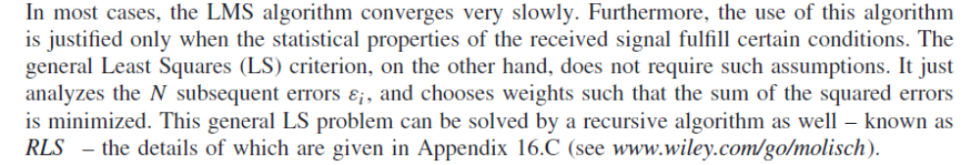
8. Discuss about space diversity with neat diagram.

Space Diversity
Another approach to achieve diversity is to use M antennas to receive M copies of the transmitted signal. The antennae should be spaced far enough apart so that different received copies of the signal undergo independent fading. Different from frequency diversity and temporal diversity, no additional work is required on the transmission end, and no additional bandwidth or transmission time is required.
However, physical constraints may limit its applications. Sometimes, several transmission antennae are also employed to send out several copies of the transmitted signal. Spatial diversity can be employed to combat both frequency selective fading and time selective fading.
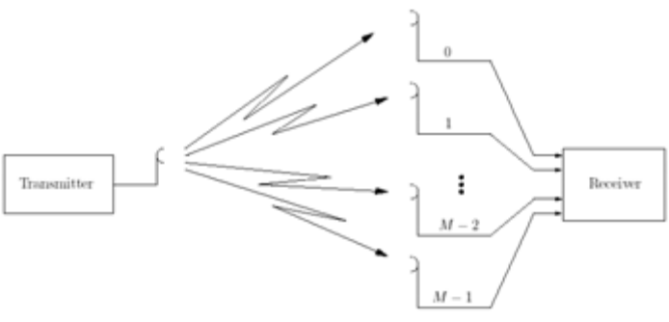
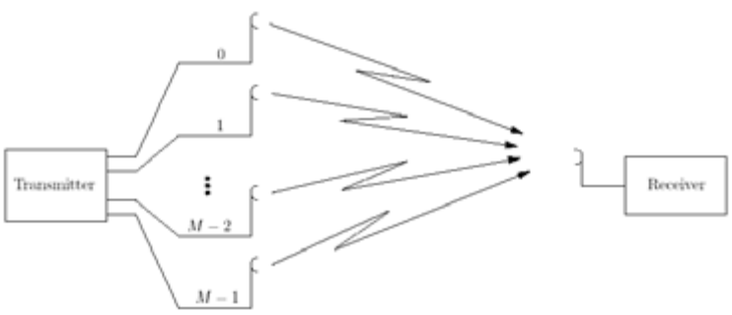
9. Explain about theoretical model for polarization diversity.
A. Basic principles and types of polarization diversityIt has been shown that propagation characteristics in wireless communication systems are different for vertically and horizontally polarized waves [6]. Multiple reflections between the transmitter and the receiver lead to depolarization of radio waves, coupling some energy of the transmitted signal into the orthogonal polarized wave. Due to that characteristic of multipath radio channel, vertically/horizontally polarized transmitted waves have also horizontal/vertical component (i.e., additional diversity branch) as illustrated in Fig. 1. In this figure, T denotes transmitted, vertically polarized wave, while R denotes received signal. Due to multipath propagation, along with the copolarized component Ry, there is also a cross-polarized component Rx. In the case of insufficient depolarization, the power imbalance between the received signal components can be very large, leading thus to low diversity gain. The parameter that indicates the power difference between the average power of the copolarized and cross-polarized signals, is denoted as cross-polar discrimination (XPD). High XPD values can lead to significant degradation of the system performance. Typical values of this parameter vary from 1−10 dB in urban/suburban environment, and 10 − 18 dB in rural environment
. 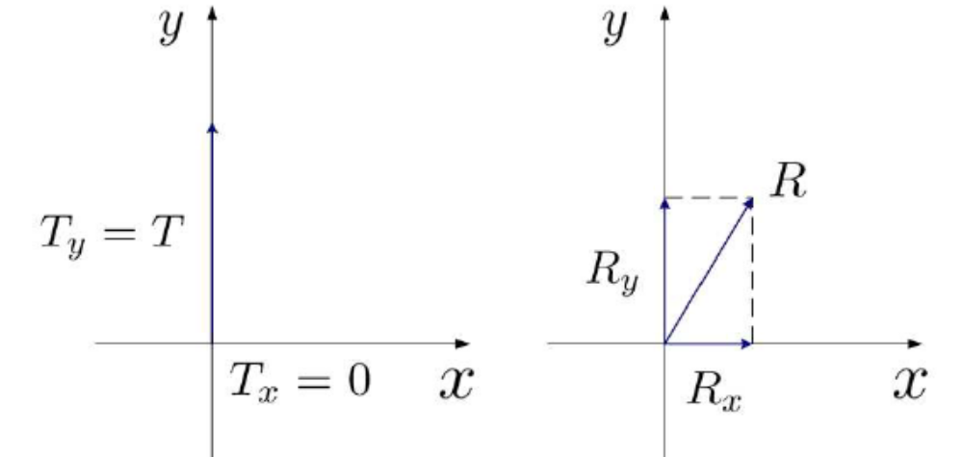
Another very important parameter describing a polarization diversity system is the correlation coefficient between the received signal envelopes. Since polarization diversity assumes utilization of only one dual-polarized antenna, the resulted configuration necessarily leads to certain signal correlation.However, studies have shown that multiple antenna systems can achieve a significant diversity gain as long as the correlation coefficient is less than 0.7 [8]. When polarization diversity is considered, this requirement is almost always fulfilled. In fact, experimental results have shown that envelope correlation coefficient is generally even less than 0.2 [7]. Therefore, polarization diversity presents a space and cost effective solution, appearing attractive for both network operators who suffer lack of space for mounting antennas, and mobile manufacturers who provide mobile terminals with limited size. A typical configuration of polarization diversity system consists of one transmit and one dual-polarized receive antenna (i.e., maximal diversity order of two), as illustrated in Fig. 2.

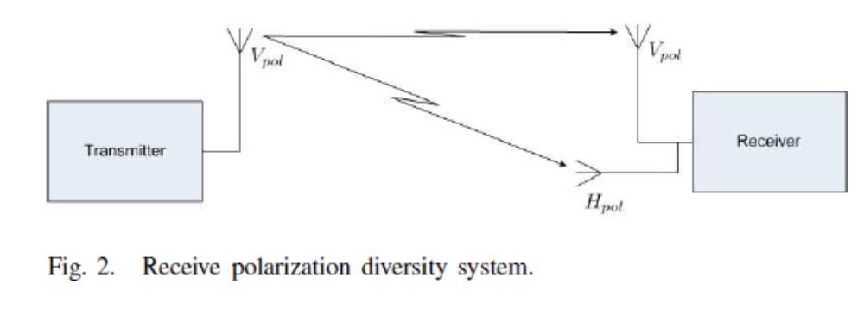
10. Discuss the performance of a RAKE receiver.
• RAKE receiver, used specially in CDMA cellular systems, can combine multipath components
– To improve the signal to noise ratio (SNR) at the receiver – Provides a separate correlation receiver for each of the multipath signals
– Multipath components are practically uncorrelated when their relative propagation delay exceeds one chip period
• Due to reflections from obstacles a radio channel can consist of many copies of originally transmitted signals having – different amplitudes, phases, and delays
• Multipath can occur in radio channel in various ways – Reflection, diffraction, scattering
• The RAKE receiver uses a multipath diversity principle – It rakes the energy from the multipath propagated signal components
• M-ray multipath model can be used – Each of the M paths has an independent delay, t, and an independent complex timevariant gain, G
– t(t) is transmitted signal
– r(t) is received signal
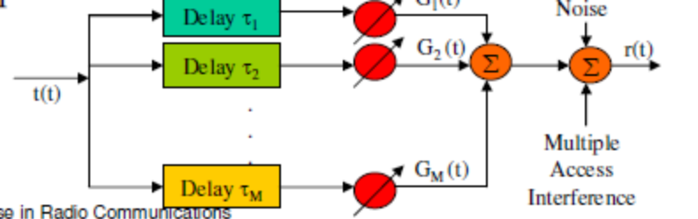
- Discuss about types of speech coders.
1. Waveform coders use source models only implicitly to design an adaptive dynamical system which maps the original speech waveform on a processed waveform that can be transmitted with fewer bits over the given digital channel. The decoder essentially inverts encoder processing to restore a faithful approximation of the original waveform. All waveform coders share the property that an increase of the bit rate will asymptotically result in lossless transcoding of the original PCM waveform. For such systems, the definition of a coding error signal as the difference between the original and the decoded waveform makes sense (although it is no immediate measure of the perceptual relevance of the distortion introduced).
2. Model-based coders or vocoders rely on an explicit source model to represent the speech signal using a small set of parameters which the encoder estimates, quantizes, and transmits over the digital channel. The decoder uses the received parameters to control a real-time implementation of the source model that generates the decoded speech signal. An increase of the bit rate will result in saturation of the speech quality at a nonzero distortion level which is limited by systematic errors in the source model. Only recently, model-based coders have advanced to a level where these errors have little perceptual impact, allowing their use for very-low-rate applications (2.4 kbit/s and below) with slightly reduced quality constraints. Furthermore, due to the signal generation process in the decoder, the decoded waveform is not synchronized with the original waveform and, therefore, the definition of a waveform error is useless to characterize the distortion of model-based coders.
3. Hybrid coders aim at the optimal mix of the two previous designs. They start out with a modelbased approach to extract speech signal parameters but still compute the modeling error explicitly on the waveform level. This model error or residual waveform is transmitted using a waveform coder whereas the model parameters are quantized and transmitted as side information. The two information streams are combined in the decoder to reconstruct a faithful approximation of the waveform such that hybrid coders share the asymptotically lossless coding property with waveform coders. Their advantage lies in the explicit parameterization of the speech model which allows us to exploit more advanced models than is the case with pure waveform coders which rely on a single invertible dynamical system for their design.
UNIT V
PART A
1. What are the two types of spread spectrum multiple access?
Direct sequence multiple access, Frequency hopped multiple access.
2. What are the two types of frequency hopping techniques?
Fast frequency hopping and Slow frequency hopping.
3. What do you mean by Fast frequency hopping?
A fast frequency hopping system is one where frequency hopping takes place faster than the data rate. Fast frequency hopping changes the carrier frequency several times during transmission of one symbol.
4. What is slow frequency hopping?
Slow frequency hopping transmits one or several symbols on each frequency.
5. How the power control is done in the uplink?
For the uplink, power control is vital for the proper operation of CDMA. Power control is done by a closed loop. The MS first sends with a certain power, the BS then tells the MS whether the power is too high or too low and the MS adjusts its power accordingly.
6. What is OFDM?
Orthogonal frequency division multiplexing splits the information into N parallel streams, which are then transmitted by modulating N distinct carriers.
7. Define cyclic prefix.
In OFDM, delay dispersion leads to a loss of orthogonality between the subcarriers and thus leads to Inter Carrier Interference (ICI). These negative effects can be eliminated by a special type of guard interval called the cyclic prefix.
8. What are the second generation standards are available?
Global system mobile (GSM) in Europe, Interim Standard 136 (IS-136), Pacific Digital Cellular (PDC) in Japan, Interim Standard (IS-95) in North America.
9. What are the services offered by GSM?
i. Telephone services ii. Bearer services iii. Supplementary services
10. Write about telephone services of GSM.
i. Teleservices provide communication between two and user applications according to a standard protocol. ii. GSM mainly focuses on voice-oriented teleservices. iii. Emergency calling and facsimile. iv. GSM also supports videotext and teletext.
11. What are the subsystems available in GSM system?
i. Base station subsystem (BSS) ii. Network and Switching subsystem (NSS) iii. Operation support subsystem.
12. What are the databases available in NSS of GSM?
Home location register (HLR), Visitor location register (VLR), Authentication center (AuC).
13. Write the functions of HLR.
1. HLR is a database which contains subscriber information and location information for each user who resides in the same MSC.
2. Each subscriber has International Mobile Subscriber Identity (IMSI) andthis number is used to identify each home user.
14. What is the function of VLR?
It is a database which temporarily stores IMSI and customer information for each roaming subscriber who is visiting the coverage area of a particular MSC.
15. What are the basic channels available in GSM?
Traffic channels and Control channels. Traffic channels carry user data and control channels carry signaling and synchronizing commands between the BS and MS.
16. What are the channels in IS-95 supported by forward link?
Pilot channel, synchronization channel, paging and traffic channel.
17. What is the main objective of 3G system?
To provide fairly high speed wireless communications to support multimedia data and video in addition to voice.
18. Write the advantages of WLL.
Low cost, easy installation.
19. What is Bluetooth?
Bluetooth is an open specification for short range wireless voice and data communications that was originally developed for cable replacement in personal area networking to operate all over the world.
20. What is piconet?
It is a collection of Bluetooth devices which are synchronized to the same hopping sequence.
PART B
1. Explain about UMTS.
To discuss how a mobile network provider may introduce UMTS, we have to distinguish between the MS, the Radio Access Network (RAN), and the CN. The MS and the UMTS Terrestrial Radio Access Network (UTRAN) communicate with each other via the air interface, as discussed in the previous section. The UTRAN consists of multiple Radio Network Subsystems (RNSs), each of which contains several Radio Network Controllers (RNCs), each of which controls one or several BSs (Node-Bs). The CN connects the different RNSs with each other and other networks, like ISDN and data packet networks. The CN can be based on an upgraded GSM CN or might be implemented as a completely new Internet Protocol (IP)-based network. The network functionalities for packet data are similar to the ones of the General Packet Radio Service (GPRS)
Another way of looking at the UMTS architecture is to organize it in two domains:
1. UE domain, which consists of:
◦ User Service Identity Module (USIM).
◦ Mobile Equipment (ME) consisting of:
– Terminal Equipment (TE);
– Terminal Adapter (TA);
– Mobile Termination (MT).
2. Infrastructure domain, which consists of:
◦ The access network domain consisting of:
– UTRAN.
◦ The CN domain consisting of:
– Inter Working Unit (IWU);
– serving network;
– transit network;
– home network;
– application network.
The physical properties of a link between two network entities and the signals transmitted via this link together with the functions of these signals are collectively referred to as an interface. Usually, an interface is standardized. Figure 26.1 shows the relevant interfaces in UMTS.
Hierarchical Cellular Structure
UMTS is intended to achieve global availability and thereby enable roaming worldwide. Therefore, the coverage area in UMTS is divided hierarchically into layers. The higher layers cover a bigger 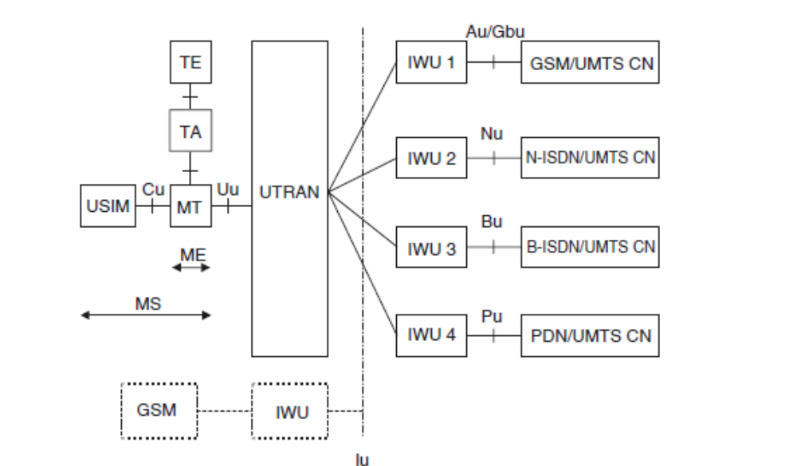
area than the lower layers. The highest layer achieves worldwide coverage by using satellites.1 The lower layers are the macrolayer, microlayer, and picolayer. They constitute the UTRAN . Each layer consists of several cells. The lower the layer the smaller the cells. Thus, the macrolayer is responsible for nationwide coverage with macrocells. Microcells are used for additional coverage in the urban environment and picocells are employed in buildings or “hotspots” such as airports or train stations. This concept is known and has been discussed and partly implemented for a while. However, UMTS was supposed to cover all aspects of this concept worldwide and with the initial rollout. In practice, however, it has been rather different: in the initial phase, only the big cities were covered with a few cells, and large-area coverage is achieved by dual-mode devices that can communicate with either WCDMA or EDGE/GPRS/GSM networks. By 2009, this rollout deployment mode is still used in the U.S.A., while Japan and most of Europe have achieved coverage of all areas with WCDMA
2. With neat diagram explain about WLL.
3. Explain the operation of Bluetooth with neat diagram.
4. Explain GSM system architecture with neat diagram.
5. Discuss about GSM channel types.
A GSM system consists essentially of three parts – namely, the Base Station Subsystem (BSS), the Network and Switching Subsystem (NSS), and the Operation Support System (OSS).
24.2.1 Base Station Subsystem
The BSS consists of Base Transceiver Stations (BTSs) and the Base Station Controllers (BSCs) (see Figure 24.1). The BTS establishes and maintains the connection to the MSs within its cell. The interface between the MS and the BTS is the air interface, called the Um-interface in the GSM context. The BTS hosts, at a minimum, the antennas and the Radio Frequency (RF) hardware of a BS, as well as the software for multiple access. Several – or, rarely, one – BTSs are connected to one BSC; they are either colocated, or connected via landline, directional microwave radio links, or similar connections. The BSC has a control functionality. It is, among other things, responsible for HandOver HO) between two BTSs that are connected to the same BSC. The interface between BTS and BSC is called the Abis-interface. In contrast to the other interfaces, this interface is not completely specified in the standard.2 Distribution of the functionalities between BTS and BSC may differ depending on the manufacturer. In most cases, one BSC is connected to several BTSs. Therefore, it is possible to increase the efficiency of implementation by shifting as much functionality as possible to the BSC. However, this implies increased signaling traffic on the link between the BTS and the BSC, which might be undesirable (remember that these links are often rented landline connections). In general, the BSS covers a large set of functionalities. It is responsible for channel assignment, maintenance of link quality and handover, power control, coding, and encryption.
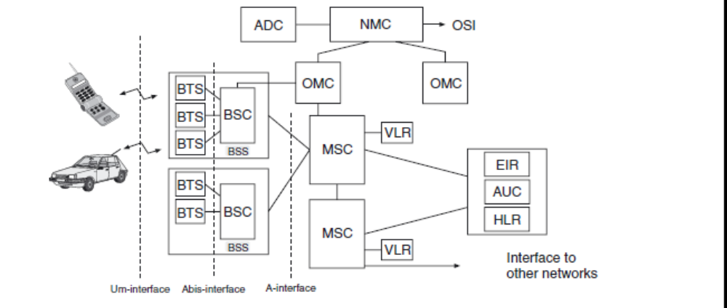
24.2.2 Network and Switching Subsystem
The main component of the NSS is the Mobile-services Switching Center (MSC), which controls he traffic between different BSCs (see Figure 24.1). One function of the MSC is mobility management, which comprises all the functions that are necessary to enable true mobility for subscribers. To give but one example, one function of the MSC is the management of HOs that occur when an MS is leaving the area of one BSC and moving into the area covered by another BSC. Other functions are the so-called paging and location update. All interactions with other networks – especially the landline Public Switched Telephone Network (PSTN) – are also performed by the MSC. The NSS includes some databases, too. The Home Location Register (HLR) contains all the numbers of the mobile subscribers associated with one MSC and information bout the location of each of these subscribers. In the event of an incoming call, the location of the desired subscriber is looked up in the HLR and the call is forwarded to this location.3 Therefore, we can conclude that from time to time a traveling MS has to send updates of its location to its HLR. The Visitor Location Register (VLR) of one MSC contains all the information about mobile subscribers from other HLRs that are in the area of this MSC and are allowed to roam in the network of this MSC. Furthermore, a temporary number will be assigned to the MS to enable the “host” MSC to establish a connection to the visiting MS.
The AUthentication Center (AUC) verifies the identity of each MS requesting a connection. The Equipment Identity Register (EIR) contains centralized information about stolen or misused devices.
24.2.3 Operating Support System
The OSS is responsible for organization of the network and operational maintenance. More specifically, the OSS mainly covers the following functions:
1. Accounting: how much does a specific call cost for a certain subscriber? There are also plenty of different services and features, from which each subscriber may choose an individual selection included in a specific plan. While this rich choice of services and prices is vital in the marketplace, the administrative support of this individualism is rather complicated.
2. Maintenance: the full functionality of each component of the GSM network has to be maintained all the time. Malfunctions may either occur in the hardware or in the software components of the system. Hardware malfunctions are more costly, as they require a technician to drive to the location of the malfunction. In contrast, software is nowadays administrated from a central location. For example, new versions of switching software can be installed in the complete BSS from a central location, and activated all over the network at a specific time. Revision and maintenance software often constitutes a considerable part of the overall complexity of GSM control software.
3. MS management: even though all MSs have to pass a type approval, it may happen that “bad apple” devices, which cause systemwide interference, are operating in the network. These devices have to be identified and their further activities have to be blocked.
4. Data collection: the OSS collects data about the amount of traffic, as well as the quality of the links.
6. Explain about IS 95 forward channel.
Error Correction Coding for 8.6 kbit/s in the Uplink
Forward error correction is different for 8.6 kbit/s and 13.3 kbit/s. However, it is identical for two existing vocoders that are based on 8.6-kbit/s output: the IS-96A vocoder and the EVRC vocoder. These vocoders are associated with rate-set-1, and thus have the following encoding steps:
1. Encoding starts with 172 bits for each 20-ms frame from the vocoder.
2. In a next step, 12 Frame Quality Indicator (FQI) bits are added. These bits act as parity check
bits, and allow determination of whether the frame has arrived correctly or not.
3. Adding an 8-bit encoder tail brings the number of bits to 192.
4. These bits are then encoded with a rate-1/3 convolutional encoder with constraint length 9. The
three generator polynomials are:
G1(D) = 1 + D2 + D3 + D5 + D6 + D7 + D8
G2(D) = 1 + D + D3 + D4 + D7 + D8
G3(D) = 1 + D + D2 + D3 + D4 + D5 + D8
Error Correction Coding for 13.3 kbit/s in the Uplink
For the CDG-13 coder, encoding steps are in principle similar, but different numerical values are used:
1. Encoding starts with 267 bits (including some unused bits) for each 20-ms frame.
2. A frame erasure bit is added.
3. A total of 12 FQI bits are added (again, to indicate whether the frame has arrived correctly).
4. Adding an 8-bit tail in order to help the Viterbi decoder. This brings the number of bits per 20-ms frame to 288.
5. These bits are then encoded with a rate-1/2 convolutional encoder with constraint length 9. The two generator polynomials are:
G1(D) = 1 + D + D2 + D3 + D5 + D7 + D8
G2(D) = 1 + D2 + D3 + D4 + D8
Error Correction Coding for 8.6 kbit/s in the Downlink
Error correction coding is somewhat different in the downlink. It uses the same combination of FQI bits and tail bits as the uplink, but then uses a rate-1/2 convolutional encoder to bring the bit rate to 19.2 kbit/s. The generator vectors are given by Eq. (25.4). Data with rate 19.2 kbit/s are then further processed as described in Section 25.3.4.
Error Correction Coding for 13.3 kbit/s in the Downlink
This mode uses the same encoding steps as the 13.3-kbit/s uplink procedure. However, this leads to a 28.8-kbit/s rate, while only 19.2 kbit/s can be transmitted in one downlink traffic channel. The output from the convolutional encoder is thus punctured, in order to yield the desired bit rate. We can also interpret this as encoding the vocoder output using a rate-3/4 convolutional code. Puncturing eliminates the third and fifth bit of each 6-bit symbol repetition block (see above). This corresponds to eliminating 2 bits created by G2(D), while the bits from G1(D) are completely transmitted.
Interleaving
Output from the convolutional encoder is sent through a block interleaver (see Section 14.7.1) of length 576 for rate set 2. More specifically, the interleaver has a matrix structure similar to the one outlined in Figure 14.25 with 32 rows and 18 columns. The data are written line by line – i.e., filling first the first column, then the second column, and so on – and read out orthogonally (see, again,
25.5 Spreading and Modulation
25.5.1 Long and Short Spreading Codes and Walsh Codes
IS-95 uses three types of spreading codes: long spreading codes, short spreading codes, and Walsh codes. These codes play different roles in the uplink and the downlink. In this section, we describe just the codes themselves. In the subsequent two sections, we describe how those codes are used in the uplink and downlink, respectively.
Databurst Randomization and Gating for the Uplink
Up to now we have considered the case when the output of the channel coder actually has a data rate of 28.8 kbit/s – i.e., a source rate of 14.4 or 9.6 kbit/s. However, depending on the source, data, lower rate (14.4 kbit/s, 7.2 kbit/s, or 3.6 kbit/s) can also be the output of a convolutional encoder. In
this case, encoded symbols are repeated (several times, if necessary) until a data rate of 28.8 kbit/s is achieved. It is these repeated data that are sent to the block interleaver for further processing.However, it would waste resources to transmit all of these repeated data at full power. or the uplink, this problem is solved by gating off the transmitter part of the time. If, e.g., the coded data rate is 14.4 kbit/s (source data rate 7.2 kbit/s), then the transmitter is turned on only 1/2 of the time. As a consequence, average transmit power is only 1/2 of the full-data-rate case, and the interference seen by other users is only half as large. Determination of the time for gating off the transmitter is actually quite complicated. The first issue is that gating has to be coordinated with the interleaver. For example, for the 7.2-kbit source data rate mode, each 1.25-ms-long group of output symbols is repeated once.3 Gating thus eliminates one of these two symbol groups. A decision about which of two symbol groups actually gets transmitted is determined by the long spreading equence, according to the following algorithm:
• Consider the second-to-last 1.25-ms symbol group in the frame (20-ms period) immediately preceding the currently considered frame.
• Take the last 14 bits of the long spreading sequence used for spreading this symbol group, label them as [b0, b1, . . . , b13].
• The gating of the symbol groups in the currently considered frame is now determined by these bits. Transmission is done of some of the 15 symbol groups contained in a 20-ms frame:
◦ for the 14.4 (9.6) kbit/s source rate mode, always transmit;
◦ for the 7.2 (4.8) kbit/s mode, transmit the first of the two identical groups if bi = 0, i =0, . . . , 7, otherwise transmit the second frame;
◦ for the 3.6 (2.4) kbit/s mode, transmit during b2i + 4i, i = 0, . . . ,3 if bi+8 = 0 or transmit during 2 + b2i+1 + 4i if bi+8 = 1;
◦ for the 1.8 (1.2) kbit/s mode, transmit during b4i + 8i, i = 0, . . . , 1 if b2i+8 = 0 and bi+12 = 0, or transmit during 2 + b4i+1 + 8i if b2i+8 = 1 and bi+12 = 0, or transmit during 4 + b4i+2 + 8i if b2i+9 = 0 and bi+12 = 1, or transmit during 6 + b4i+3 + 8i if b2i+9 = 1 and bi+12 = 1. Thus, the gating of sequences is pseudorandom, and different for each user (remember that the long spreading sequence is different for each user). Thus, in a system with low-rate users, interference with other users is “smeared out” – i.e., no user sees interference from all other users at the same time. 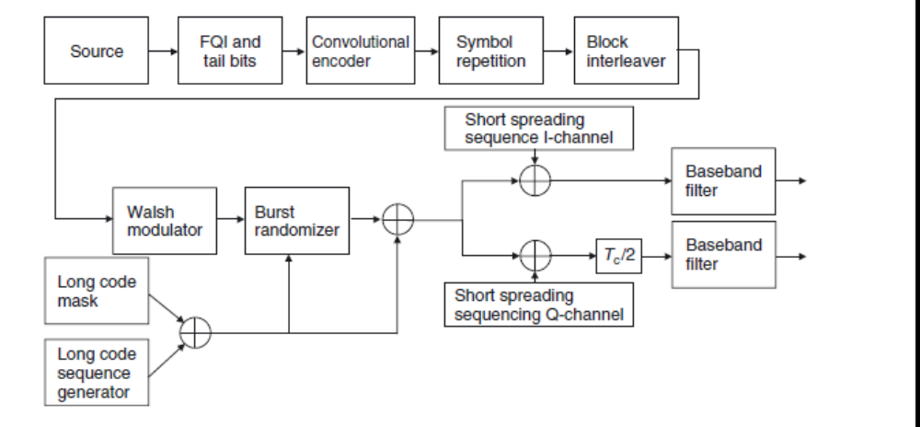
7. Explain about IS 95 reverse channel.
8. Explain frequency hopping spread spectrum in detail.
9. Explain cellular code division multiple access system.
10. Explain the effects of multipath propagation on CDMA.
11. Discuss about orthogonal frequency division multiplexing.

